# Generated QA Summary

--- Entry for custom_id: d5c4b87e0dba11ecb1e81171463288e9 ---

Image Source 1 -



Caption for image source 1: Frangipani flowers Frangipani (Plumeria) flowers in Perth, Western Australia.

Example Question - "What color is the center part of a Frangipani flower?"

Example Answer - "The center part of a Frangipani flower is yellow."

Additional Text Source 1 - One of the heavenly damsels in the frescoes of the fifth-century rock fortress Sigiriya holds a 5-petalled flower in her right hand that is indistinguishable from plumeria. In Eastern Africa, frangipani are sometimes referred to in Swahili love poems. (from: Plumeria)

Generated Question - How many petals does the flower held by the damsel in the Sigiriya fresco likely have based on the Frangipani flower shown?

Generated Answer - The flower likely has five petals, like the Frangipani flower shown.

--- Entry for custom_id: d5bf37a00dba11ecb1e81171463288e9 ---

Image Source 1 -

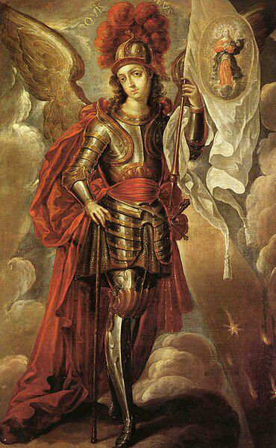

Caption for image source 1: San Miguel Arcángel - Cristóbal de Villalpando Saint Michael the Archangel.

Image Source 2 -

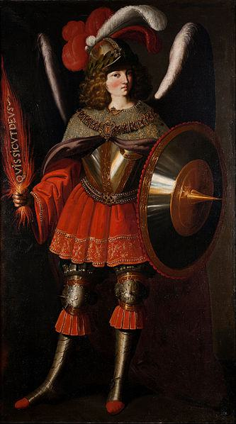

Caption for image source 2: Francisco de Zurbarán and Studio - The Archangel Michael - Google Art Project.

Example Question - "Saint Michael the Archangel's helmet had longer plumage on which painting: The Archangel Michael or Saint Michael the Archangel?"

Example Answer - "The Archangel Michael had longer plumage."

Additional Text Source 1 - A similar painting, this time with the Archangel Michael himself slaying a serpent, then became a major art piece at the Michaelion and eventually lead to the standard iconography of Archangel Michael as a warrior saint. (from: Michael (archangel))

Generated Question - Which painting shows the Archangel Michael holding a shield, Saint Michael the Archangel or The Archangel Michael?

Generated Answer - The Archangel Michael shows the Archangel Michael holding a shield.

--- Entry for custom_id: d5cc89be0dba11ecb1e81171463288e9 ---

Image Source 1 -

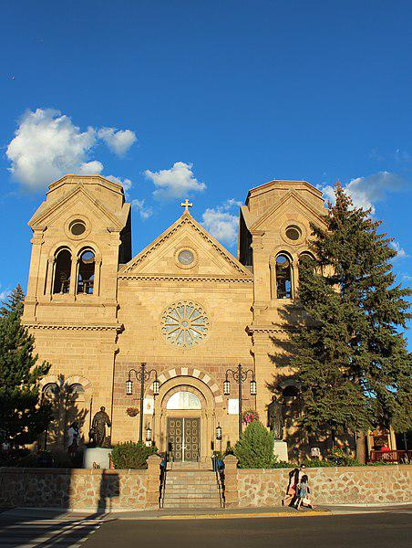

Caption for image source 1: Santa Fe, New Mexico, USA - Cathedral Basilica of St. Francis of Assisi - panoramio.

Image Source 2 -

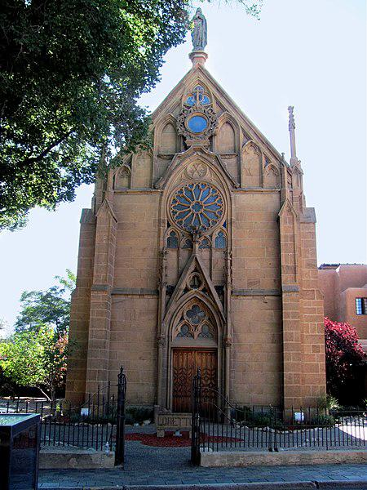

Caption for image source 2: Santa Fe, New Mexico, USA - Loretto Chapel - panoramio (1).

Example Question - "When it comes to the form of window on their facades, what do the Loretto Chapel and the Cathedral Basilica of St. Francis of Assisi have in common?"

Example Answer - "When it comes to the form of window on their facades, the Loretto Chapel and the Cathedral Basilica of St. Francis of Assisi have rose windows in common."

Additional Text Source 1 - The Cathedral Basilica of Saint Francis of Assisi (Spanish: Catedral basílica de San Francisco de Asís), commonly known as Saint Francis Cathedral, is a Roman Catholic cathedral in downtown Santa Fe, New Mexico. (from: Cathedral Basilica of St. Francis of Assisi (Santa Fe))

Generated Question - Are both the Cathedral Basilica of St. Francis of Assisi and the Loretto Chapel located in the same city and state?

Generated Answer - Yes, both are located in Santa Fe, New Mexico.

--- Entry for custom_id: d5cb1d860dba11ecb1e81171463288e9 ---

Image Source 1 -

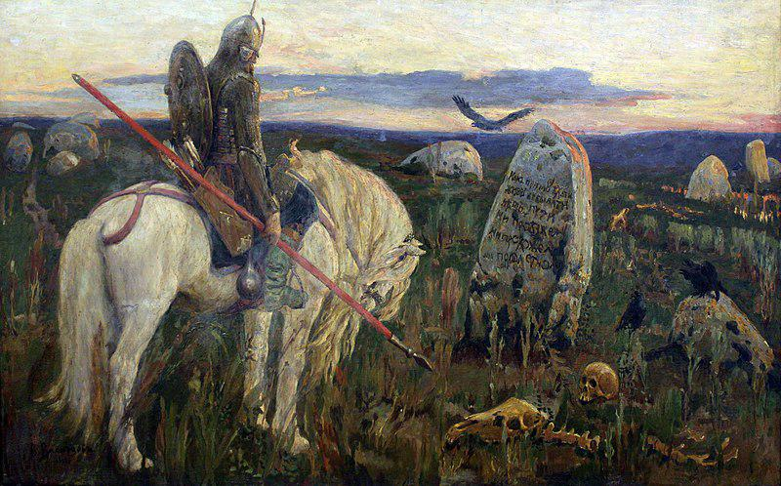

Caption for image source 1: 1919 Vasnetsov Ritter an der Kreuzung anagoria Viktor Mikhailovich Vasnetsov A knight at the crossroads.

Example Question - "What kind of weapon does the horse rider have in his hand in A Knight at the Crossroads?"

Example Answer - "The horse rider has a spear in his hand."

Additional Text Source 1 - This idea was then completely lost in later wars or was perverted by Nazi Germany, which awarded a "Knight's Cross" as an award. Conversely, the Austrian priest and resistance fighter Heinrich Maier is referred to as Miles Christi, a Christian knight against Nazi Germany. (from: Knight)

Generated Question - How does the knight in the painting symbolize the original concept of a knight compared to the later Nazi use of the term "Knight's Cross"?

Generated Answer - The knight in the painting represents a traditional warrior, unlike the Nazi perversion of the "Knight's Cross" award.

--- Entry for custom_id: d5ca078e0dba11ecb1e81171463288e9 ---

Image Source 1 -



Caption for image source 1: Spaltblättlinge.

Example Question - "Is the Spaltblättlinge shaped as a shell?"

Example Answer - "Yes, the Spaltblättlinge is shell-shaped."

Image Source 2 -



Generated Question - Do both images show Spaltblättlinge growing on wood with similar fan-shaped, gilled structures?

Generated Answer - Yes, both images show Spaltblättlinge growing on wood with fan-shaped, gilled structures.

--- Entry for custom_id: d5c605800dba11ecb1e81171463288e9 ---

Image Source 1 -

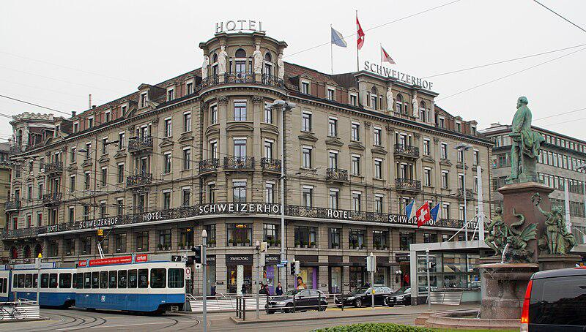

Caption for image source 1: 2015-03-25 Bahnhofplatz7 This photo was taken by Robert Kropf (User:TheRunnerUp) and released under the license CC BY-SA 4.0..

Example Question - "How many statues are on the Schweizerhof Hotel in Bahnhofplatz?"

Example Answer - "There are 6 statues on the roof of the Schweizerhof Hotel in Bahnhofplatz."

Additional Text Source 1 - Some of the city's most recognisable buildings are hotels from this period, such as the Schweizerhof Hotel (1845), Grand Hotel National (1870), and Château Gütsch (1879). (from: Lucerne)

Generated Question - Are the Schweizerhof Hotel and Château Gütsch from the same century based on their construction years?

Generated Answer - Yes, both were built in the 19th century.

--- Entry for custom_id: d5c44d440dba11ecb1e81171463288e9 ---

Image Source 1 -

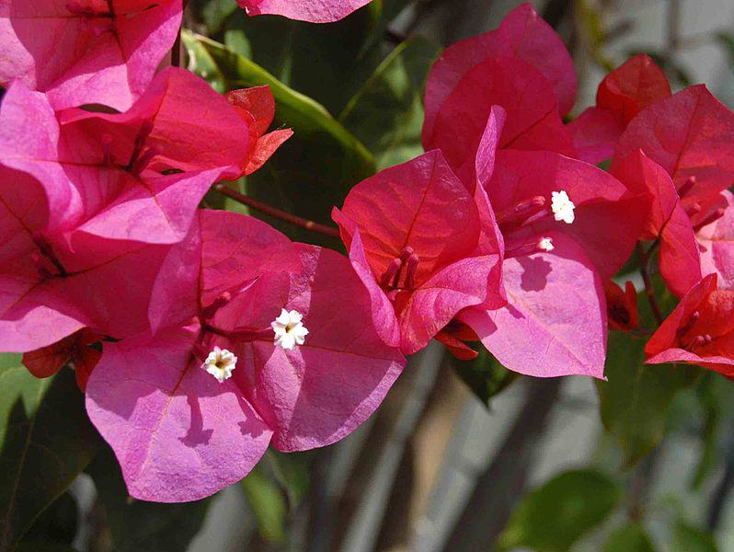

Caption for image source 1: Nyctaginaceae - Bougainvillea buttiana Flower surrended by bracts of Bougainvillea buttiana.

Image Source 2 -

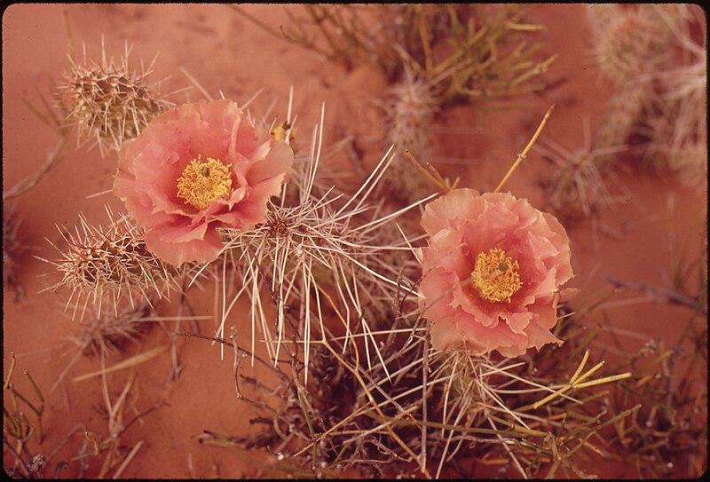

Caption for image source 2: ORANGE MALLOW, SHOWY DESERT FLOWER - NARA - 544877.

Example Question - "Is the Orange Globe Mallow and the Nyctaginaceae filamnet both pink?"

Example Answer - "No, the Orange Globe Mallow and the Nyctaginaceae filamnet are not both pink."

Image Source 3 -

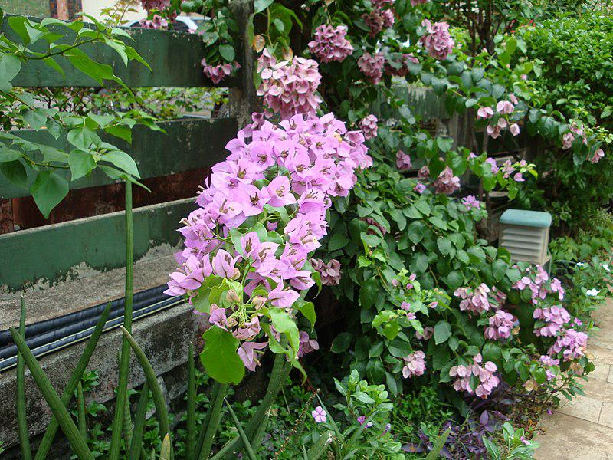

Generated Question - Are the flowers in the first and additional images both Bougainvillea but differ in color?

Generated Answer - Yes, both are Bougainvillea but the first is bright pink and the additional is light pink.

--- Entry for custom_id: d5da60840dba11ecb1e81171463288e9 ---

Example Question - What elements are used to create the explosive forces used by the technology that's currently being explored as a higher velocity alternative to conventional artillery?

Example Answer - Hydrogen and oxygen.

Image Source 1 -

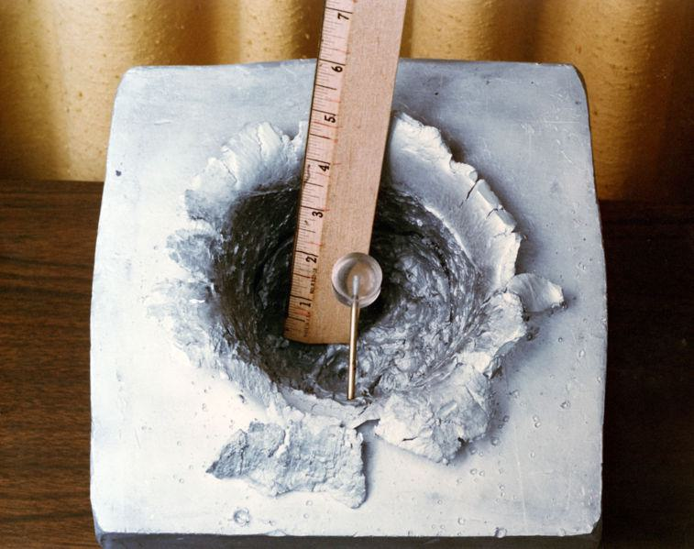

Generated Question - How does the velocity achieved by the combustion light-gas gun compare to conventional artillery using nitrocellulose propellants?

Generated Answer - The combustion light-gas gun achieves much higher velocities, such as 23,000 feet per second, compared to conventional artillery.

--- Entry for custom_id: d5c385620dba11ecb1e81171463288e9 ---

Image Source 1 -

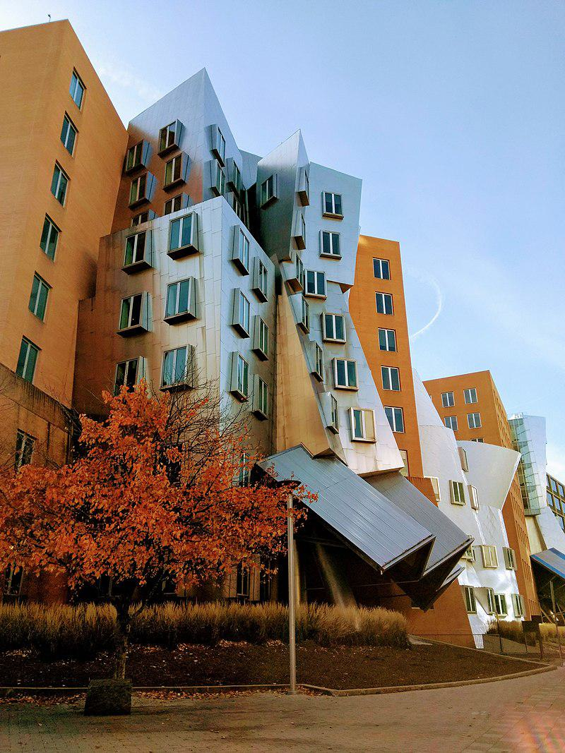

Caption for image source 1: Stata Center -MIT photo by Linda Fletcher.

Image Source 2 -

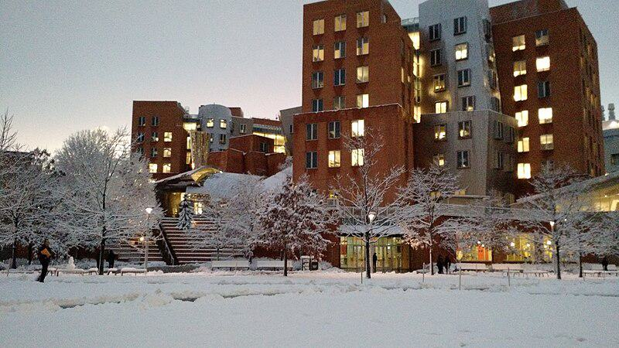

Caption for image source 2: Stata Center snow 2016 The Stata Center on the MIT Campus in snow, February 2016.

Example Question - "Are the buildings of the Stata Center uniform height?"

Example Answer - "The buildings of the Stata Center are not of uniform height."

Additional Text Source 1 - The wall and trees provide a uniform background for the chapel, and isolate the site from the noise and bustle of adjacent buildings. (from: MIT Chapel)

Generated Question - Does the Stata Center maintain a uniform architectural style and height compared to the uniform background described for the MIT Chapel site?

Generated Answer - No, the Stata Center has varied heights and a non-uniform architectural style unlike the uniform background of the MIT Chapel site.

--- Entry for custom_id: d5dd1d740dba11ecb1e81171463288e9 ---

Example Question - Which person gave the island into which Somes Sound runs its name?

Example Answer - Samuel de Champlain gave Mount Desert Island, the island into which Somes Sound runs, its name.

Image Source 1 -

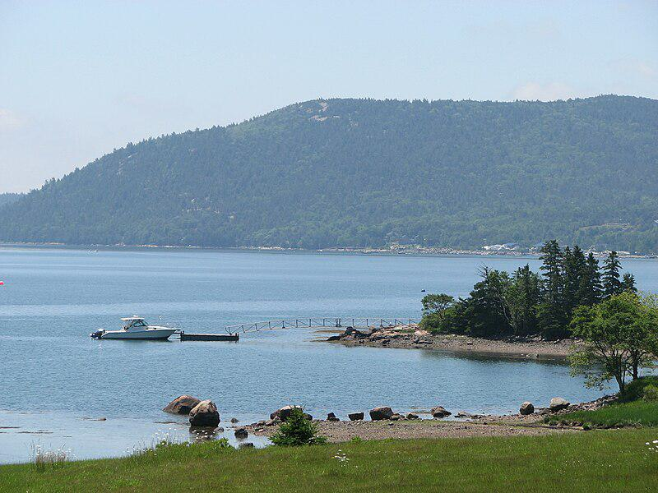

Generated Question - What type of water body is Somes Sound, and on which island is it located?

Generated Answer - Somes Sound is a fjard located on Mount Desert Island.

--- Entry for custom_id: d5bfd3400dba11ecb1e81171463288e9 ---

Image Source 1 -

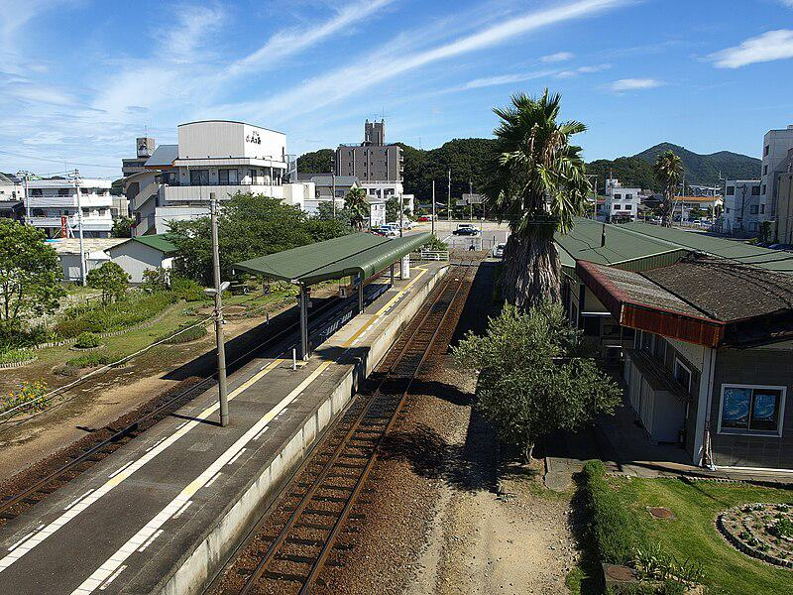

Caption for image source 1: Naruto railway station (overview) Naruto railway station overview ,Tokushima, Japan..

Example Question - "How many railway tracks appear at the Naruto railway station in Tokushima, Japan?"

Example Answer - "There are two railway tracks at the Naruto Railway Station in Tokushima, Japan."

Additional Text Source 1 - Naruto Station (鳴門駅, Naruto-eki) is railway station on the Naruto Line in Naruto, Tokushima Prefecture, Japan. It is operated by JR Shikoku and has the station number "N10". (from: Naruto Station)

Generated Question - Does Naruto Station in Tokushima have more than one platform for boarding trains?

Generated Answer - Yes, Naruto Station has two platforms for boarding trains.

--- Entry for custom_id: d5bfa64a0dba11ecb1e81171463288e9 ---

Image Source 1 -

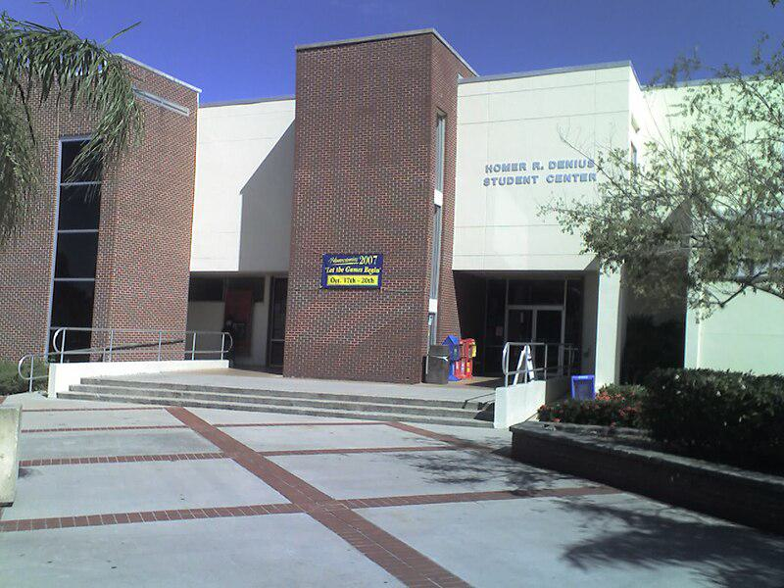

Caption for image source 1: FlTechSUB Florida Institute of Technology's Homer Denius Student Union Building, home to the campus bookstore, university mail annex, SUB Cafe, Office of Student Life, the John and Martha Hartley Room, as well as several student organizational offices..

Example Question - "Are there railings at the Florida Institute of Technology's Homer Denius Student Union Building?"

Example Answer - "Yes, there are railings."

Additional Text Source 1 - The Denius Student Center and Shaw Hall at Florida Tech are named in their honor. The Evans Library Special Collections Department collaborated with retired Radiation, Inc. employees in collecting materials for the Radiation, Inc. Archives. (from: Florida Institute of Technology)

Generated Question - Is the Homer Denius Student Union Building at Florida Tech associated with any special collections or archives?

Generated Answer - Yes, it is connected to the Radiation, Inc. Archives through the Evans Library.

--- Entry for custom_id: d5c3e5160dba11ecb1e81171463288e9 ---

Image Source 1 -



Caption for image source 1: The Rat (Graffiti in London) Banksy rat graffiti on City Road, London, United Kingdom..

Image Source 2 -

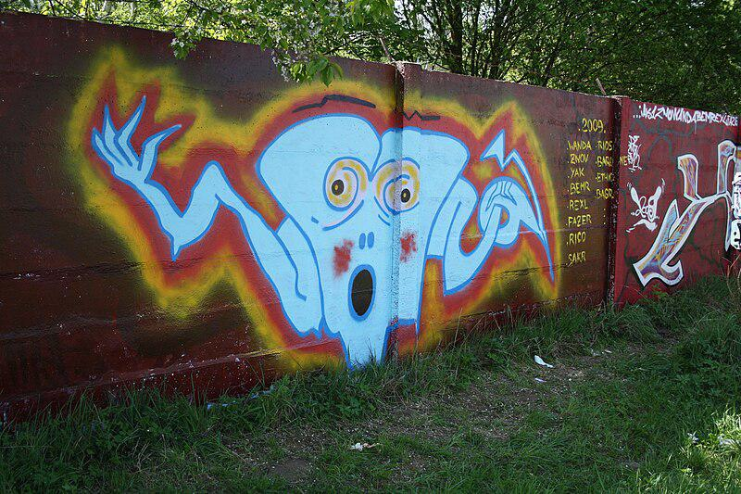

Caption for image source 2: Graffiti 47 on legal wall of PBS (2009) in Třebíč, Třebíč District Graffiti on legal wall of PBS factory in Trebic-Jejkov, Czech Republic..

Example Question - "What colors were used in the cartoon character in the Graffiti on legal wall of PBS factory that were not used in Banksy rat graffiti on City Road in London?"

Example Answer - "Red, blue, and yellow were used in the graffiti at the legal wall of PBS."

Additional Text Source 1 - In July 2020, Banksy painted a series of sneezing rats on a Circle Line train on the London Underground. These were removed by cleaners for violating TFL's anti-graffiti policies. (from: Works by Banksy that have been damaged or destroyed)

Generated Question - Considering Banksy's rat graffiti on City Road and the sneezing rats on the London Underground, which location's rat graffiti was removed due to policy violations?

Generated Answer - The sneezing rats on the London Underground were removed for violating TFL's anti-graffiti policies.

--- Entry for custom_id: d5c9d2460dba11ecb1e81171463288e9 ---

Image Source 1 -

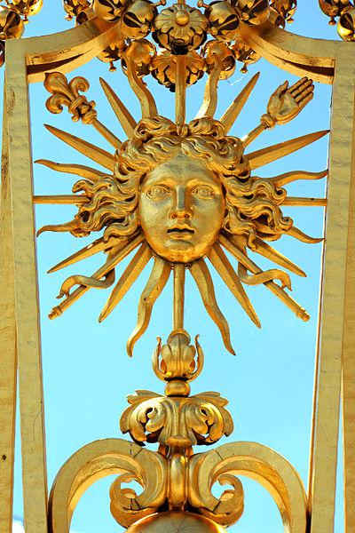

Caption for image source 1: Palace of Versailles - Louis XIV, 22 June 2014.

Example Question - "What human body part can be found on one of the spikes around the head on the Grille royale of Versailles, France?"

Example Answer - "A hand can be found on one of the spikes around the head on the Grille Royale of Versailles, France."

Additional Text Source 1 - In 2003, a new restoration initiative – the "Grand Versailles" project – was started, which began with the replanting of the gardens, which had lost over 10,000 trees during Hurricane Lothar on 26 December 1999. One part of the initiative, the restoration of the Hall of Mirrors, was completed in 2006. (from: Palace of Versailles)

Generated Question - How does the restoration of the Palace of Versailles relate to the preservation of the Grille Royale's golden sun face?

Generated Answer - The restoration initiative helps preserve features like the Grille Royale's golden sun face by maintaining the palace and gardens.

--- Entry for custom_id: d5ca8bfa0dba11ecb1e81171463288e9 ---

Image Source 1 -



Caption for image source 1: Marissa Castelli Simon Shnapir 2013 U.S. Figure Skating Pairs Champions Marissa Castelli and Simon Shnapir stand atop the podium after becoming the 2013 U.S. Figure Skating Pairs Champions.

Example Question - "What color did Marissa Castelli wear after becoming the 2013 U.S. Figure Skating Pairs Champion?"

Example Answer - "Marissa Castelli wore the color red after becoming the 2013 U.S. Figure Skating Pairs Champion."

Additional Text Source 1 - Marissa Castelli (born August 20, 1990) is an American retired pair skater. With her skating partner, Mervin Tran, she is the 2017 U.S. national silver medalist. (from: Marissa Castelli)

Generated Question - Did Marissa Castelli win the 2013 U.S. Figure Skating Pairs Championship with Simon Shnapir or Mervin Tran?

Generated Answer - Marissa Castelli won the 2013 championship with Simon Shnapir, not Mervin Tran.

--- Entry for custom_id: d5d868b00dba11ecb1e81171463288e9 ---

Example Question - The public use Falcon Field and the state-owned facility located west of Adak in Alaska are both types of what?

Example Answer - Airports.

Image Source 1 -

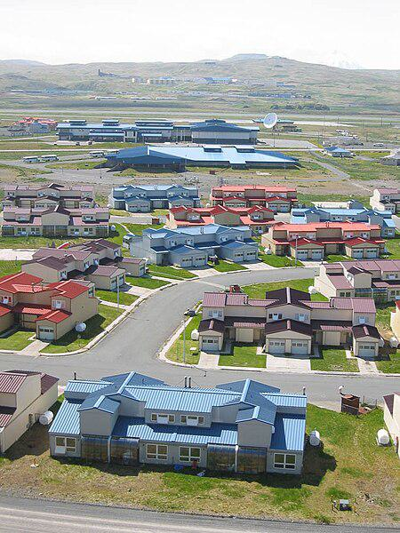

Generated Question - Are both the Atlanta Regional Airport and the airport near the residential area in Adak, Alaska public use airports?

Generated Answer - Yes, both are public use airports.

--- Entry for custom_id: d5ddccba0dba11ecb1e81171463288e9 ---

Example Question - What type of armor and weapons would Spartacus have likely worn as a gladiator?

Example Answer - He would have probably worn a small rectangular, square or circular shield and a very short sword with a slightly curved blade.

Image Source 1 -

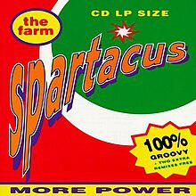

Generated Question - How does the image of the album cover titled "Spartacus" relate to the historical figure Spartacus and his gladiator weapons?

Generated Answer - The album cover uses the name "Spartacus" but does not depict the gladiator's typical shield or short curved sword.

--- Entry for custom_id: d5bf5dd40dba11ecb1e81171463288e9 ---

Image Source 1 -

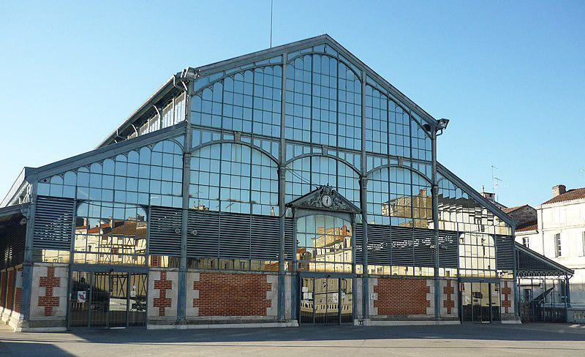

Caption for image source 1: Halles de Niort.

Example Question - "How many people are around the clock in the sculpture over the door of the Halles de Niort?"

Example Answer - "There are 4 people around the clock."

Additional Text Source 1 - The Donjon de Niort or Château de Niort (the former is most often used today) is a medieval castle in the French town of Niort in the département of Deux-Sèvres. It consists of two square towers, linked by a 15th-century building and dominates the Sèvre Niortaise valley. (from: Donjon de Niort)

Generated Question - Is the architectural style of Halles de Niort similar to the medieval Donjon de Niort castle in Niort?

Generated Answer - No, Halles de Niort has a modern glass and metal style, unlike the medieval stone castle.

--- Entry for custom_id: d5db3c160dba11ecb1e81171463288e9 ---

Example Question - In Arthurian legend, the father of Lancelot and Hector de Maris takes which king's sister-in-law to be his wife?

Example Answer - Ban marries the sister to King Bors's wife.

Image Source 1 -

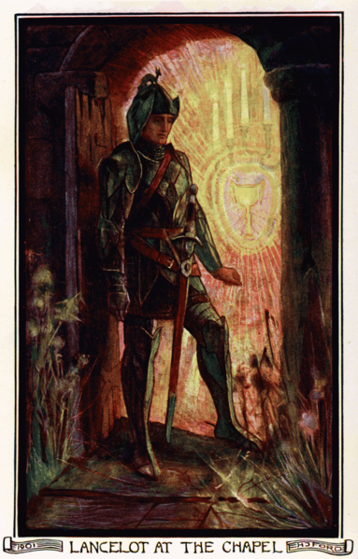

Generated Question - How is Lancelot related to King Ban and King Bors according to the Arthurian legend sources and the image caption?

Generated Answer - Lancelot is King Ban's son and King Bors's nephew.

--- Entry for custom_id: d5da5b7a0dba11ecb1e81171463288e9 ---

Example Question - How big is the diameter of the smooth cap in the mycorrhizal organism that lives in symbiosis with the trees?

Example Answer - About 4–10 cm.

Image Source 1 -



Generated Question - How does the cap color of Amanita porphyria compare to the Death Cap shown in the image?

Generated Answer - Amanita porphyria has a brown cap with purplish or greyish hues, unlike the Death Cap's greenish cap.

--- Entry for custom_id: d5d416340dba11ecb1e81171463288e9 ---

Example Question - Did Ron McLarty or Peter Thomas live to a longer age?

Example Answer - Peter Thomas lived to a longer age.

Image Source 1 -

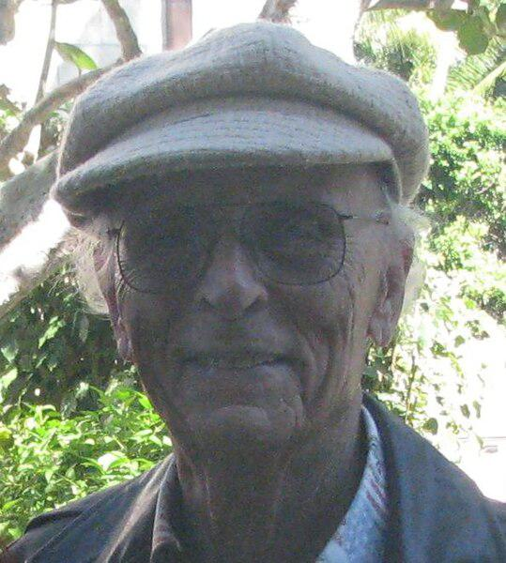

Generated Question - Considering their careers and lifespans, who had a longer career span, Peter Thomas or Ron McLarty?

Generated Answer - Peter Thomas had a longer career span of over 70 years.

--- Entry for custom_id: d5c9e6f00dba11ecb1e81171463288e9 ---

Image Source 1 -

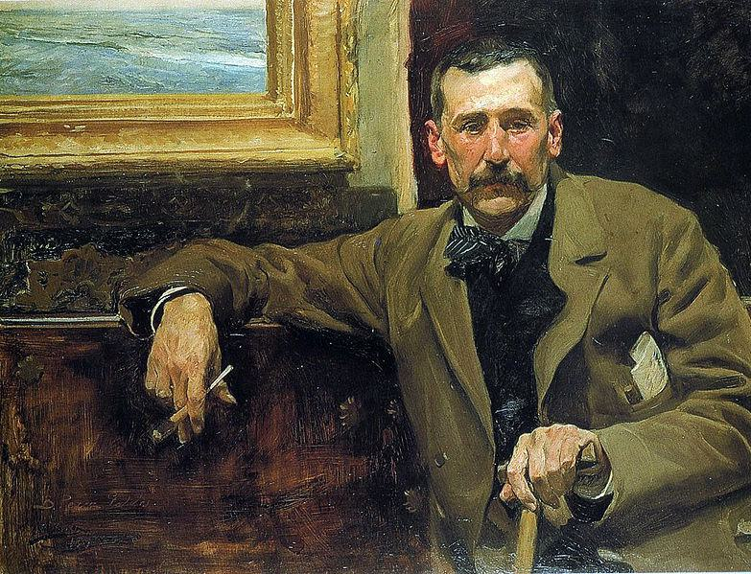

Caption for image source 1: Perez galdos.

Image Source 2 -

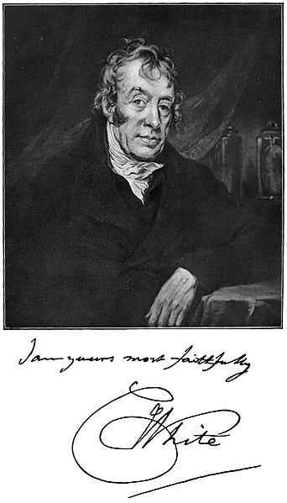

Caption for image source 2: White Charles physician Picture of Charles White, the physician.

Example Question - "Are the men in Joaquín Sorolla's "Portrait of Benito Pérez Galdós" and photograph of "Picture of Charles White, the physician" (taken in 1904) sitting down?"

Example Answer - "The men in Joaquín Sorolla's "Portrait of Benito Pérez Galdós" and photograph of "Picture of Charles White, the physician" (taken in 1904) are sitting down."

Additional Text Source 1 - Benito Pérez Galdós (May 10, 1843 – January 4, 1920) was a Spanish realist novelist. He was the leading literary figure in 19th-century Spain, and some scholars consider him second only to Miguel de Cervantes in stature as a Spanish novelist. (from: Benito Pérez Galdós)

Generated Question - Were both Benito Pérez Galdós and Charles White notable figures in their respective fields during the 19th century?

Generated Answer - Yes, Benito Pérez Galdós was a leading 19th-century Spanish novelist, and Charles White was a physician from that era.

--- Entry for custom_id: d5d589ba0dba11ecb1e81171463288e9 ---

Example Question - Who were the parents of the god in Norse mythology projected as the husband of the goddes Frigg?

Example Answer - Odin is the son of Bestla and Borr

Image Source 1 -

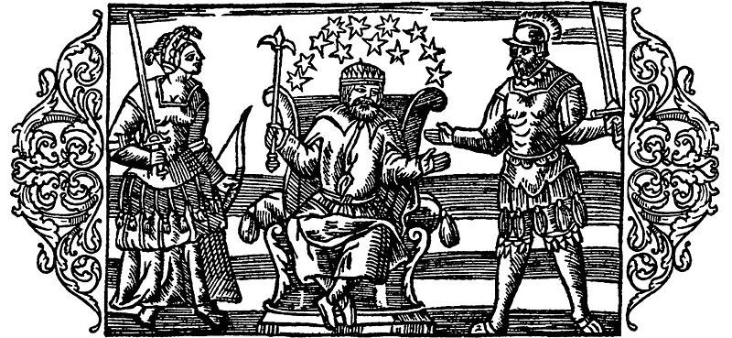

Generated Question - Which Norse god depicted in the image is known as the son of Bestla and Borr and husband of the goddess Frigg?

Generated Answer - Odin is the son of Bestla and Borr and husband of Frigg.

--- Entry for custom_id: d5dd0c9e0dba11ecb1e81171463288e9 ---

Example Question - What color are the bill and feet of the bar-tailed trogon and the belly of the male black-throated trogon?

Example Answer - yellow

Image Source 1 -

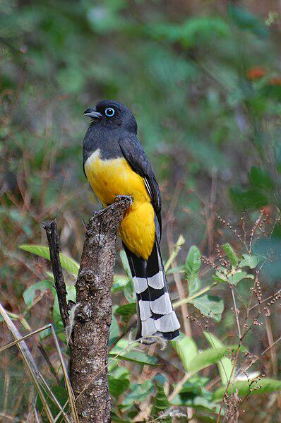

Generated Question - How do the undertail patterns of the bar-tailed trogon and the male black-headed trogon differ based on their descriptions and image?

Generated Answer - The bar-tailed trogon's undertail is narrowly barred with black and white, while the male black-headed trogon has a distinct black and white banded undertail pattern.

--- Entry for custom_id: d5ccb01a0dba11ecb1e81171463288e9 ---

Image Source 1 -

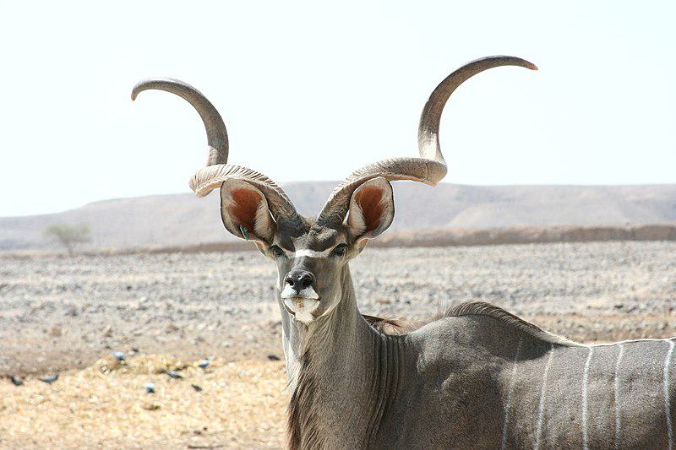

Caption for image source 1: Kudu antelope Kudu at antelpe ranch, Israel.

Example Question - "What shape are the horns of a Kudu Antelope?"

Example Answer - "The horns of the Kudu Antelope are spiral shaped."

Additional Text Source 1 - Kudu ( koo-DOO), or koodoo, is the Khoikhoi name for this antelope. Trag- (Greek) denotes a goat and elaphos (Greek) a deer. (from: Greater kudu)

Generated Question - How does the name "Kudu" relate to the animal shown in the image and what does the Greek origin of its scientific name imply about its characteristics?

Generated Answer - "Kudu" is the Khoikhoi name for the antelope, and its Greek scientific name implies it has traits of both a goat and a deer.

--- Entry for custom_id: d5bca3140dba11ecb1e81171463288e9 ---

Image Source 1 -

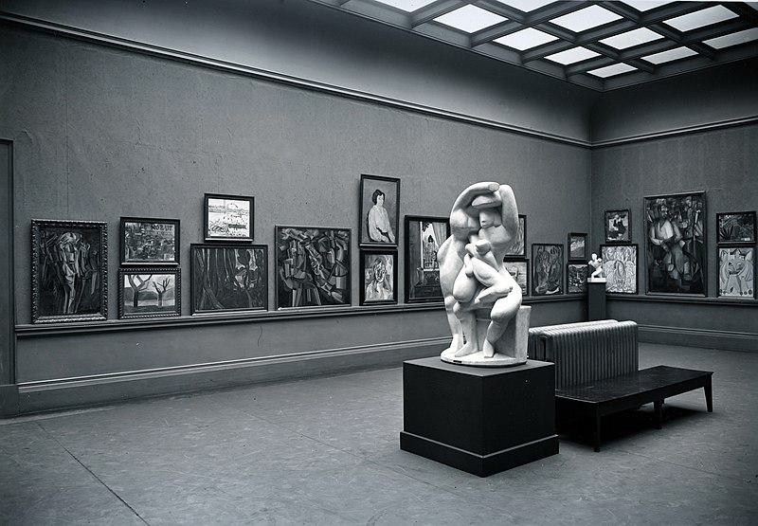

Caption for image source 1: Armory Show, International Exhibition of Modern Art, Chicago, 1913. The Cubist room.

Example Question - "How many sculptures are on display in the Cubist Room at the Armory Show International Exhibition of Modern Art?"

Example Answer - "There are two sculptures on display in the Cubist Room at the Armory Show International Exhibition of Modern Art."

Additional Text Source 1 - The historical Armory Show of 1913 was one of the first American exhibitions to showcase a form of art that had yet to reach the United States. The first large scale exhibition of modern art in America this exhibition showcased the artistic movement known as cubism which made artists like Pablo Picasso and Georges Braque so famous. (from: Edith L. King)

Generated Question - How did the Armory Show of 1913 influence American exposure to Cubism as seen in the Cubist Room?

Generated Answer - The Armory Show of 1913 was the first large-scale exhibition to introduce Cubism to America, showcasing works by artists like Picasso and Braque.

--- Entry for custom_id: d5c704120dba11ecb1e81171463288e9 ---

Image Source 1 -



Caption for image source 1: Mycena parsonsiae 44171.

Image Source 2 -



Caption for image source 2: Mycena leaiana 58075.

Example Question - "What kind of surface can Mycena leaiana and Mycena parsonsiae grow on?"

Example Answer - "They can grow on a rock surface."

Additional Text Source 1 - Mycena leaiana is a common species, and grows in dense cespitose clusters (with stipes sharing a single point of origin) on hardwood logs and branches. (from: Mycena leaiana)

Generated Question - Do Mycena parsonsiae and Mycena leaiana both grow on hardwood logs or branches?

Generated Answer - Yes, both species grow on hardwood logs or branches.

--- Entry for custom_id: d5d43e3e0dba11ecb1e81171463288e9 ---

Example Question - Did Adrien Brody win his Academy Award for Best Actor for The Pianist in the same year that Bill Murray won a Golden Globe award for Lost in Translation?

Example Answer - no

Image Source 1 -

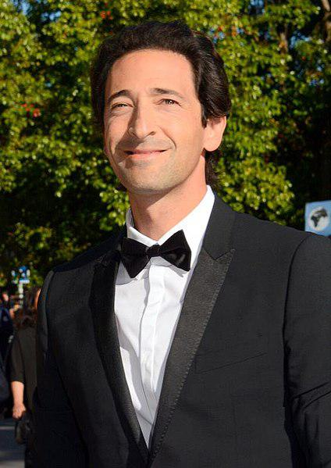

Generated Question - Did Adrien Brody win the Academy Award for Best Actor for The Pianist before Bill Murray was nominated for the same award for Lost in Translation?

Generated Answer - Yes, Adrien Brody won before Bill Murray was nominated.

--- Entry for custom_id: d5cfe1680dba11ecb1e81171463288e9 ---

Example Question - How many vase painters have been identified by people who sometimes studied disjecta membra?

Example Answer - Over 2800 painters have been identified.

Image Source 1 -

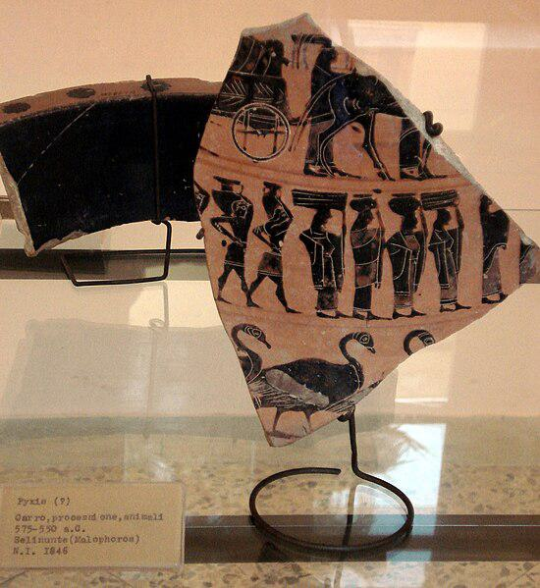

Generated Question - How do scholars identify individual ancient Greek vase painters from fragments like the disjecta membra shown in the image?

Generated Answer - Scholars attribute painted fragments to individual artists by studying their style and characteristics.

--- Entry for custom_id: d5ccabc40dba11ecb1e81171463288e9 ---

Image Source 1 -

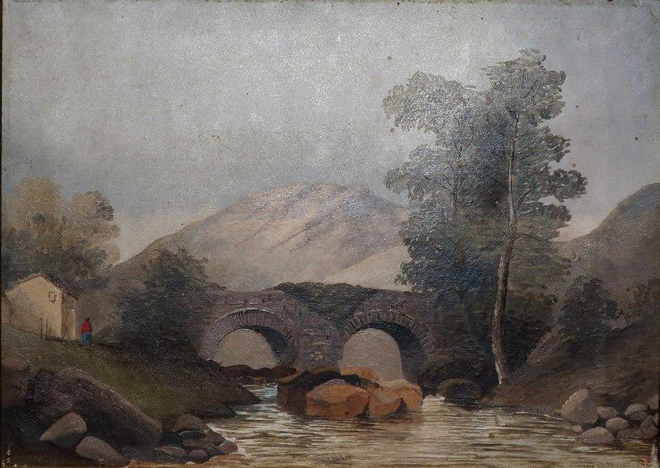

Caption for image source 1: Scottish Landscape, oil on canvas painting by Princess Victoria Kaiulani, c. 1891, Bishop Museum Scottish Landscape, oil on canvas painting by Princess Victoria Kaiulani, c. 1891, Bishop Museum.

Image Source 2 -

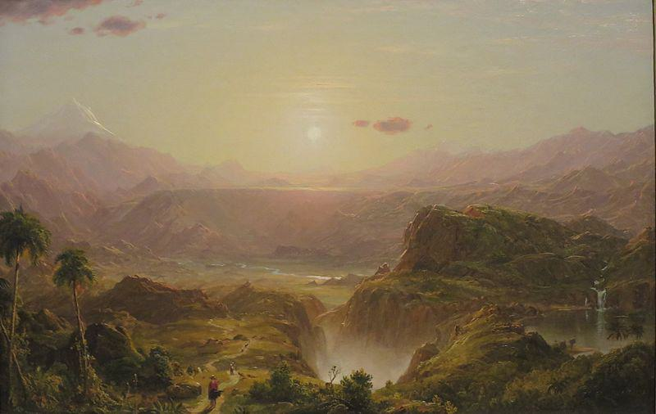

Caption for image source 2: 'The Andes of Ecuador', oil on canvas painting by Frederic Adwin Church, 1855, HAA The Andes of Ecuador oil on canvas painting by Frederic Edwin Church, 1855, Honolulu Museum of Art accession 56221.

Example Question - "In which painting is the sun visible: The Andes of Ecuador by Frederic Adwin Church or Scottish Landscape by by Princess Victoria Kaiulani?"

Example Answer - "The sun visible in the painting The Andes of Ecuador by Frederic Adwin Church."

Additional Text Source 1 - Its exhibition in 1859 was a sensation, establishing Church as the foremost landscape painter in the United States. The painting has been in the collection of New York's Metropolitan Museum of Art since 1909, and is among Church's most renowned works. (from: The Heart of the Andes)

Generated Question - Which painting depicts a mountainous landscape with a visible sun, The Andes of Ecuador or Scottish Landscape?

Generated Answer - The Andes of Ecuador depicts a mountainous landscape with a visible sun.

--- Entry for custom_id: d5c6d0aa0dba11ecb1e81171463288e9 ---

Image Source 1 -

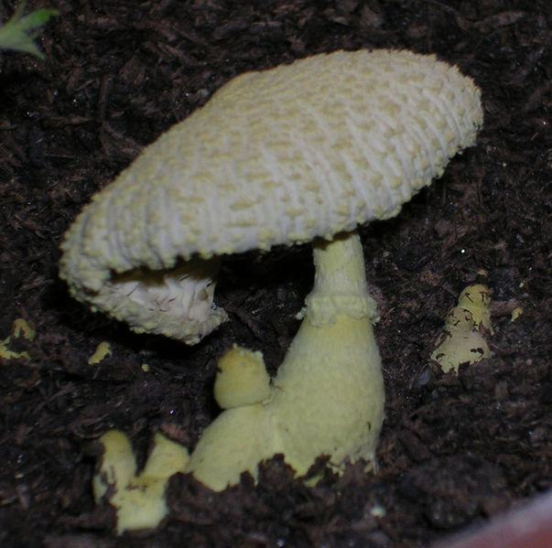

Caption for image source 1: Leucocoprinus birnbaumii.

Image Source 2 -



Caption for image source 2: Laccaria amethysteo-occidentalis (32942930552).

Example Question - "Which fungus top looks most like it was knit; Leucocoprinus birnbaumii or Laccaria amethysteo-occidentalis?"

Example Answer - "The Leucocoprinus birnbaumii fungus top looks most like it was knit."

Additional Text Source 1 - Like all Leucocoprinus species, L. birnbaumii is a saprotroph, living on very decayed plant matter (humus or compost). The fungus is common throughout the tropics and subtropics, extending into warmer parts of the temperate zones. (from: Leucocoprinus birnbaumii)

Generated Question - Considering their habitats, which fungus is more likely to be found in tropical or subtropical environments, Leucocoprinus birnbaumii or Laccaria amethysteo-occidentalis?

Generated Answer - Leucocoprinus birnbaumii is more likely found in tropical or subtropical environments.

--- Entry for custom_id: d5c9a97e0dba11ecb1e81171463288e9 ---

Image Source 1 -

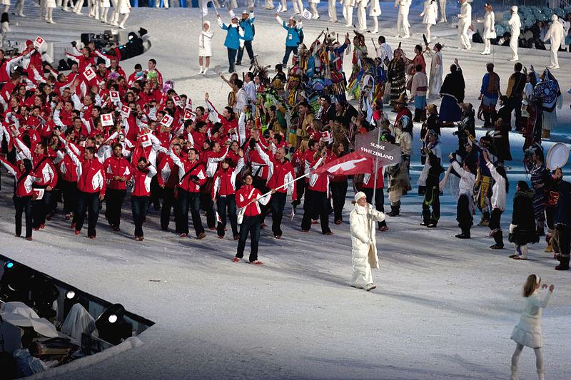

Caption for image source 1: 2010 Opening Ceremony - Switzerland entering.

Image Source 2 -

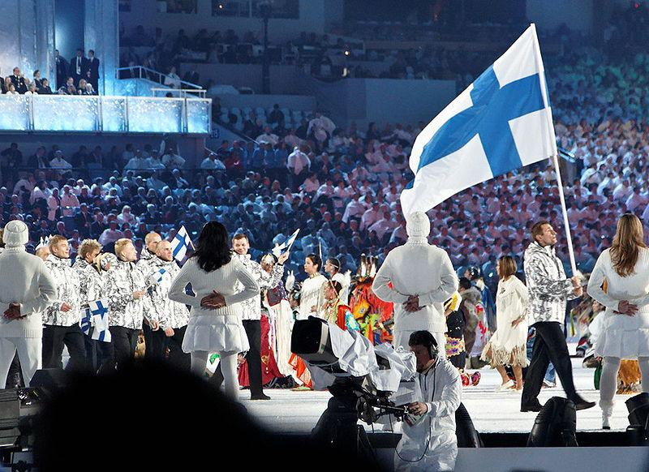

Caption for image source 2: 2010 Olympic Winter Games Opening Ceremony - Finland entering cropped.

Example Question - "Which nation in the 2010 Winter Olympics opening ceremony had more white in their uniforms: Finland or Switzerland?"

Example Answer - "Finland had more white in their uniforms than Switzerland."

Additional Text Source 1 - The Opening Ceremony of the 2006 Winter Olympics (Torino 2006) was held on 10 February 2006 beginning at 20:00 CET (UTC+1) at the Stadio Olimpico in Turin, Italy. (from: 2006 Winter Olympics opening ceremony)

Generated Question - Did the 2010 Winter Olympics opening ceremony feature teams with predominantly white uniforms like in the 2006 Winter Olympics opening ceremony?

Generated Answer - Yes, both ceremonies featured teams with predominantly white uniforms.

--- Entry for custom_id: d5cfb54e0dba11ecb1e81171463288e9 ---

Example Question - What was the name of the home arena to the Texas Stars of the American Hockey League when WrestleMania 29 took place?

Example Answer - Cedar Park Center

Image Source 1 -

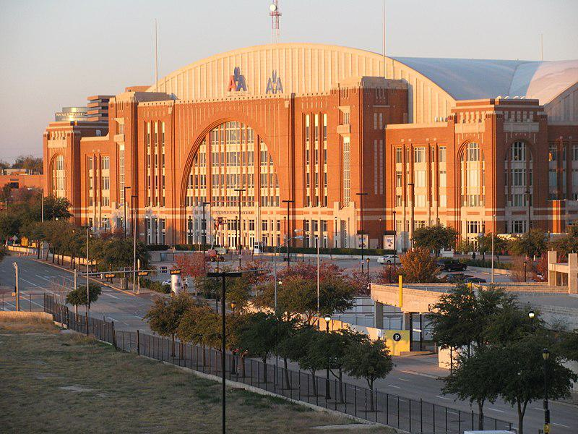

Generated Question - Which arena is currently used by the Dallas Stars, and how does it differ from the home arena of the Texas Stars?

Generated Answer - The Dallas Stars currently use the American Airlines Center, while the Texas Stars play at the Cedar Park Center.

--- Entry for custom_id: d5c449c00dba11ecb1e81171463288e9 ---

Image Source 1 -

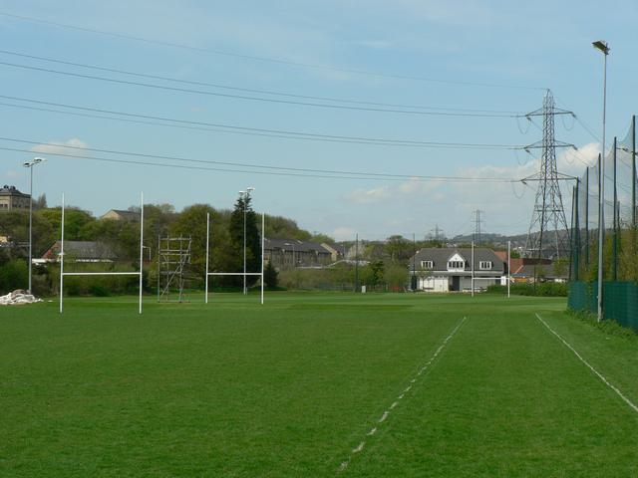

Caption for image source 1: Leeds Rugby Academy, Kirkstall - geograph.org.uk - 165339 Leeds Rugby Academy, Kirkstall. Looking along the fence on the east side adjacent to Morrisons..

Image Source 2 -

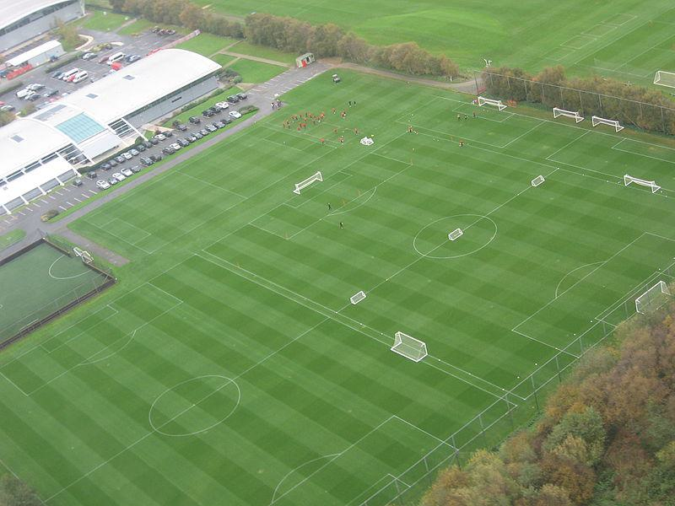

Caption for image source 2: MUFC training ground Carrington.

Example Question - "Are there light posts next to the field at both Leeds rugby Academy in kirkstall and the MUFC training ground in Carrington?"

Example Answer - "No, there are no light posts next to the field at Leeds rugby Academy in Kirkstall or the MUFC training ground in Carrington."

Additional Text Source 1 - The current academy is based at the club's Aon Training Complex, an 85-acre (340,000 m2) site in the Manchester suburb of Carrington. (from: Manchester United F.C. Reserves and Academy)

Generated Question - Do both Leeds Rugby Academy and MUFC training ground in Carrington have multiple sports fields visible in the images?

Generated Answer - Yes, both locations show multiple sports fields in the images.

--- Entry for custom_id: d5c3d3960dba11ecb1e81171463288e9 ---

Image Source 1 -

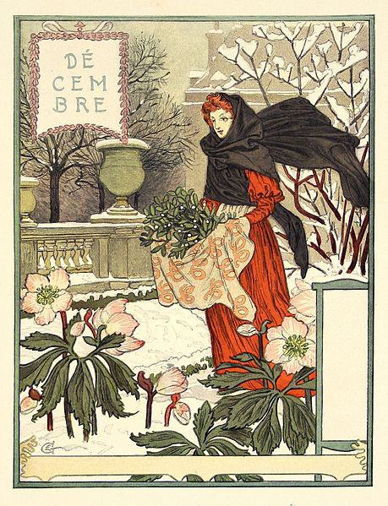

Caption for image source 1: Grasset-decembre.

Image Source 2 -

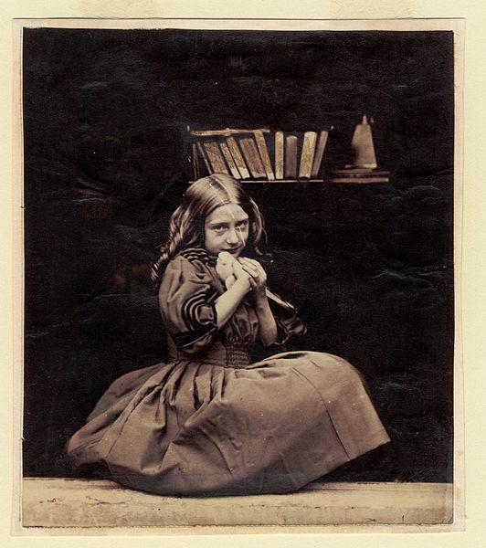

Caption for image source 2: Rejlander045 No title.

Example Question - "Which painting is more colorful, the "Decembre" by Eugène Grasset or the "Girl with dove" by Oscar Gustave Rejlander?"

Example Answer - "Decembre is more colorful than Girl with dove."

Additional Text Source 1 - Oscar Gustave Rejlander (Stockholm, 19 October 1813 – Clapham, London, 18 January 1875) was a pioneering Victorian art photographer and an expert in photomontage. (from: Oscar Gustave Rejlander)

Generated Question - Considering the artistic styles, which work reflects a more traditional photographic technique, the "Decembre" illustration or the "Girl with dove" photograph by Rejlander?

Generated Answer - The "Girl with dove" photograph reflects a traditional photographic technique, unlike the illustrated "Decembre."

--- Entry for custom_id: d5d1f1060dba11ecb1e81171463288e9 ---

Example Question - What is the weight range for squids that are part of the Cephalopod molluscs phylum?

Example Answer - They can range in weight between 0.1 kg to 495 kg.

Image Source 1 -

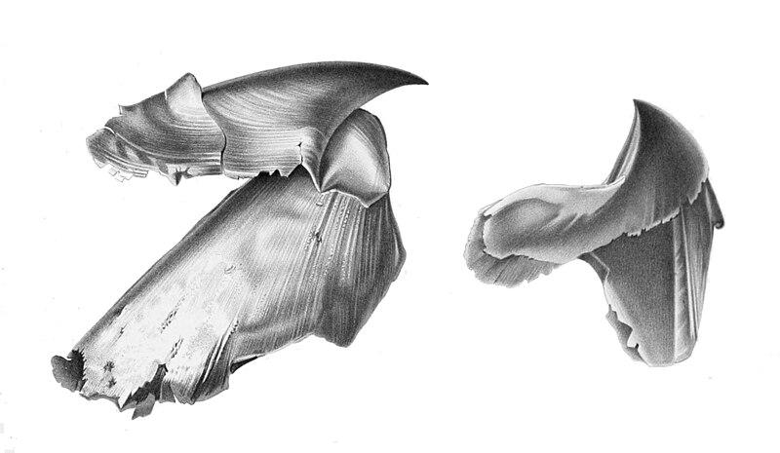

Generated Question - How does the colossal squid's weight compare to the typical size of cephalopod molluscs like the giant squid shown by its beak?

Generated Answer - The colossal squid can weigh up to 495 kg, much heavier than typical cephalopods like the giant squid, which are smaller.

--- Entry for custom_id: d5c40a8c0dba11ecb1e81171463288e9 ---

Image Source 1 -

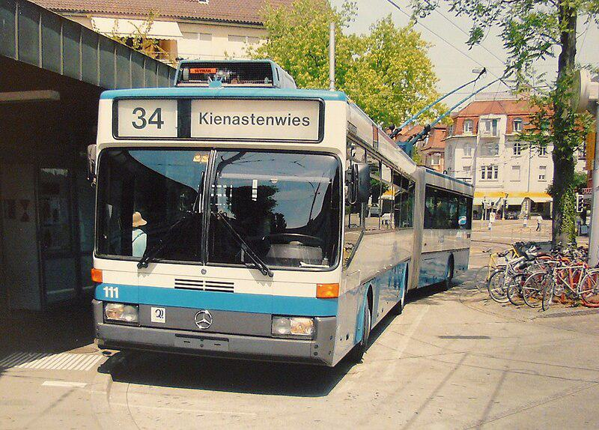

Caption for image source 1: Klausplatz Zurich trolleybus Mercedes-Benz trolleybus (#111) at Klusplatz in Zurich, Switzerland..

Example Question - "What brand of buses are used at Klusplatz in Zurich, Switzerland?"

Example Answer - "The buses at Klusplatz in Zurich, Switzerland are Mercedes Benz."

Additional Text Source 1 - Zurich Airport (German: Flughafen Zürich, IATA: ZRH, ICAO: LSZH) is the largest international airport of Switzerland and the principal hub of Swiss International Air Lines. (from: Zurich Airport)

Generated Question - Is the Mercedes-Benz trolleybus at Klausplatz in Zurich likely to connect passengers to Zurich Airport?

Generated Answer - Yes, as Zurich Airport is the main hub, the trolleybus likely serves routes connecting to it.

--- Entry for custom_id: d5d0f5c60dba11ecb1e81171463288e9 ---

Example Question - On what highway in California were there cars overturned during the outbreak of weak tornadoes in Santa Barbara and Orange Counties between January 19 and January 21, 2010?

Example Answer - The cars were overturned on the Pacific Coast Highway.

Image Source 1 -

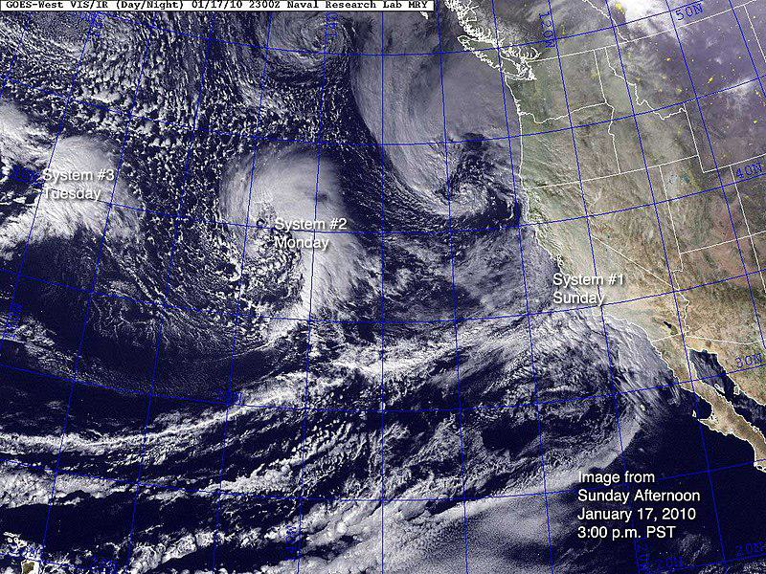

Generated Question - How many storm systems are shown in the January 17, 2010 satellite image that led to the tornado outbreak in Southern California starting January 19?

Generated Answer - Three storm systems are shown in the image.

--- Entry for custom_id: d5d0210a0dba11ecb1e81171463288e9 ---

Example Question - What title can the older youth of the Sea Scouts elect a youth leader to that is also a member of a U.S. Navy gun crew?

Example Answer - They can be given the title 'boatswain".

Image Source 1 -



Generated Question - How does the role of a boatswain in the U.S. Navy Armed Guard compare to the title given to youth leaders in the Sea Scouts recognized by the Royal Navy?

Generated Answer - Both use the title "boatswain," with the Navy role as a crew member and Sea Scouts as a youth leader.

--- Entry for custom_id: d5dde1d20dba11ecb1e81171463288e9 ---

Example Question - Egbert Benson and John Jay had descent from what people whose colonization of the Americas began with the establishment of trading posts and plantations?

Example Answer - Dutch

Image Source 1 -

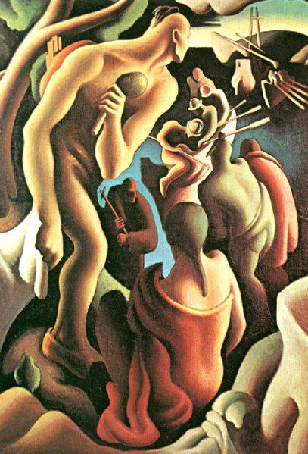

Generated Question - How did the colonization by the Dutch, ancestors of Egbert Benson and John Jay, impact the indigenous peoples depicted in the 1922 painting?

Generated Answer - The Dutch colonization, like other European colonization, had disastrous effects on indigenous peoples.

--- Entry for custom_id: d5cc0cc80dba11ecb1e81171463288e9 ---

Image Source 1 -

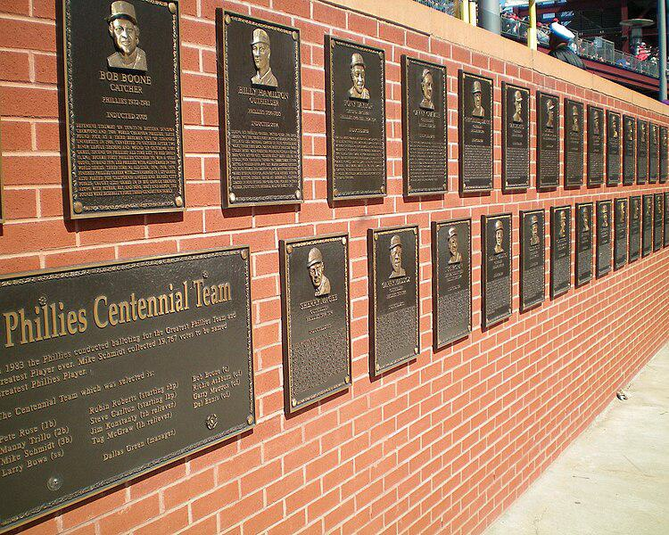

Caption for image source 1: PhilliesWallofFame This is the Phillies Wall of Fame at Citizens Bank Park, Philadelphia, PA..

Example Question - "What kind of wall holds the Phillies Wall of Fame at Citizens Bank Park, Philadelphia, PA?"

Example Answer - "A brick wall holds the Phillies Wall of Fame at Citizens Bank Park, Philadelphia, PA."

Additional Text Source 1 - The Philadelphia Baseball Wall of Fame is a collection of plaques, mounted on a brick wall next to the Left Field Gate at Citizens Bank Park, the ballpark of the Philadelphia Phillies. (from: Philadelphia Baseball Wall of Fame)

Generated Question - Are the plaques on the Phillies Wall of Fame mounted on a brick wall near the Left Field Gate at Citizens Bank Park?

Generated Answer - Yes, the plaques are mounted on a brick wall near the Left Field Gate at Citizens Bank Park.

--- Entry for custom_id: d5c0f2f20dba11ecb1e81171463288e9 ---

Image Source 1 -

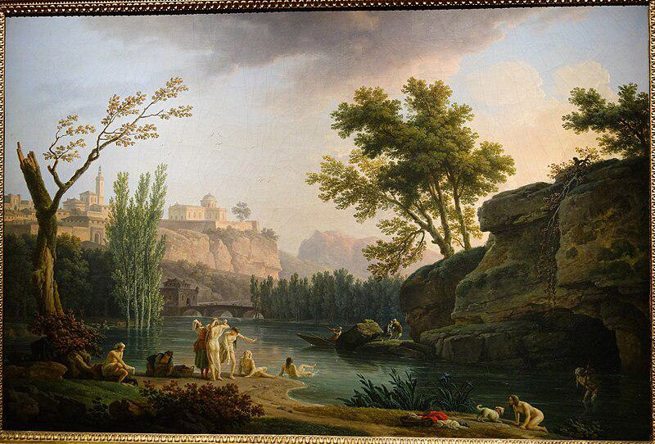

Caption for image source 1: Summer Evening, Landscape in Italy, view 2, by Joseph Vernet, 1773, oil on canvas - National Museum of Western Art, Tokyo - DSC08554 Painting in the National Museum of Western Art, Tokyo, Japan. This artwork is in the public domain because the artist died more than 70 years ago. Photography was permitted in the museum without restriction..

Image Source 2 -

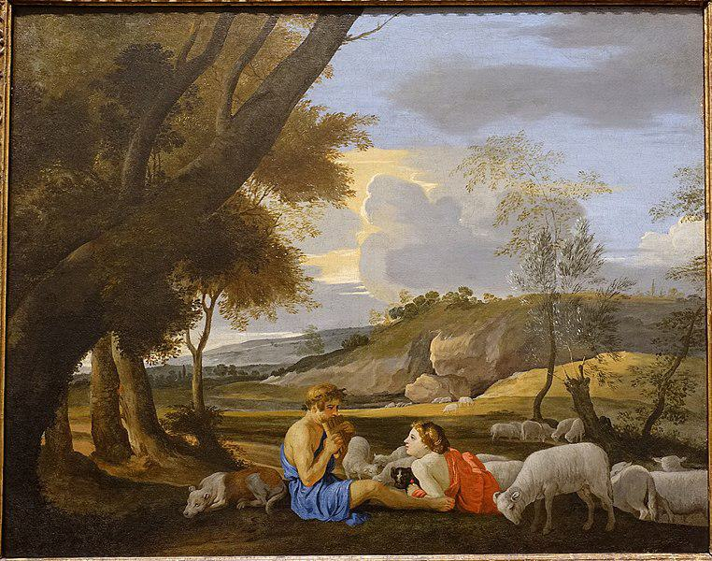

Caption for image source 2: Arcadian Landscape, by the circle of Nicolas Poussin, c. 1627-1628, oil on canvas - Blanton Museum of Art - Austin, Texas - DSC07880 Arcadian Landscape.

Example Question - "Is there a dog in Joseph Vernet's "Summer Evening, Landscape in Italy" and "Arcadian Landscape, by the circle of Nicolas Poussin"?"

Example Answer - "There is a dog in both Joseph Vernet's "Summer Evening, Landscape in Italy" and "Arcadian Landscape, by the circle of Nicolas Poussin"."

Additional Text Source 1 - The views in landscape gardens were rarely copied from real nature; they were more often inspired by romantic paintings, particularly those of Nicolas Poussin, Salvator Rosa and Claude Lorrain, who depicted Arcadian landscapes with mythological scenes. (from: French landscape garden)

Generated Question - Do both paintings depict natural landscapes with human figures interacting with animals, reflecting the Arcadian ideal?

Generated Answer - Yes, both paintings show humans with animals in natural, idealized landscapes inspired by Arcadian themes.

--- Entry for custom_id: d5d60a980dba11ecb1e81171463288e9 ---

Example Question - According to legend, Dangun founded the first kingdom in what place where monarchy existed until the end of the Japanese occupation?

Example Answer - Korea

Image Source 1 -

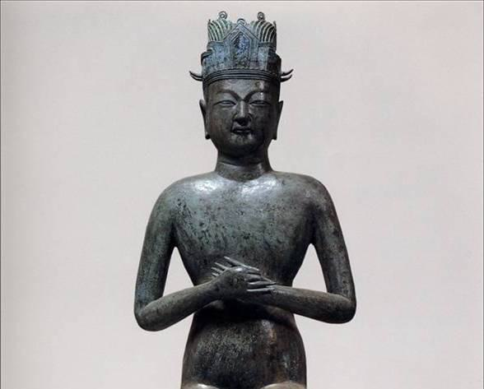

Generated Question - Which Korean dynasty's founder is represented by the bronze statue wearing a tongcheongwan, a practice originating from Goguryeo?

Generated Answer - Goryeo dynasty.

--- Entry for custom_id: d5d9ed700dba11ecb1e81171463288e9 ---

Example Question - The high peak called Golden Hinde can be found in what area that the twin summits the Lions Gate Bridge was named in their honor are in?

Example Answer - Vancouver.

Image Source 1 -

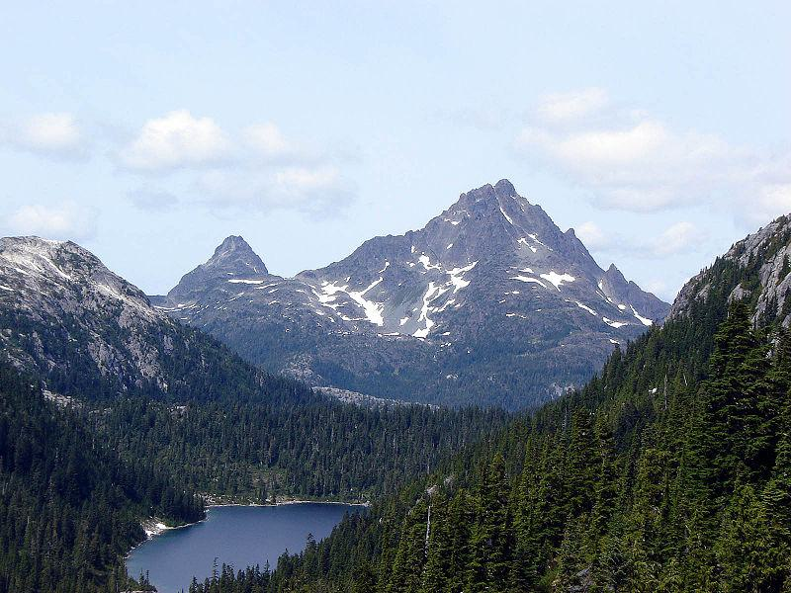

Generated Question - Are the Golden Hinde and the Lions peaks both visible from the Greater Vancouver area?

Generated Answer - No, only the Lions peaks are visible from the Greater Vancouver area.

--- Entry for custom_id: d5c555a40dba11ecb1e81171463288e9 ---

Image Source 1 -

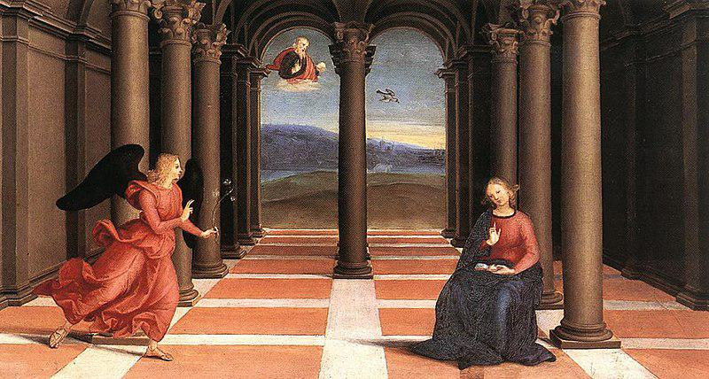

Caption for image source 1: Raphael - The Annunciation (Oddi altar).

Example Question - "What is the angel in The Annunciation Oddi altar holding in her hand?"

Example Answer - "The angel in The Annunciation Oddi Alter is holding an olive branch."

Image Source 2 -

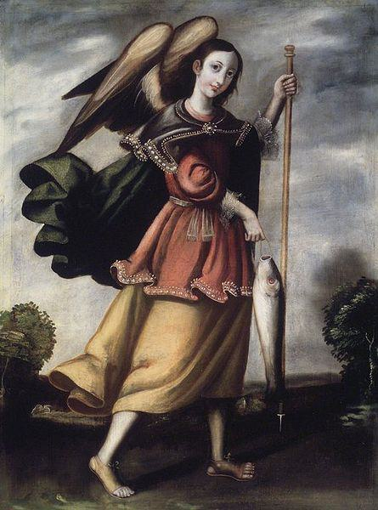

Generated Question - How do the wings of the angels in Raphael's The Annunciation and the Brooklyn Museum's Archangel Raphael differ in color and style?

Generated Answer - The angel in Raphael's The Annunciation has black wings, while the Archangel Raphael has brown wings with a more detailed feather style.

--- Entry for custom_id: d5d1e0e40dba11ecb1e81171463288e9 ---

Example Question - Does relation of ideas impact relational theory?

Example Answer - It does not.

Image Source 1 -



Generated Question - How does the relational model concept in the image illustrate the philosophical idea that relations are facts true or false of two things?

Generated Answer - The relational model shows relations as tables linking attributes, reflecting how relations connect and compare objects.

--- Entry for custom_id: d5dacd620dba11ecb1e81171463288e9 ---

Example Question - What type of rimless bottlenecked rifle cartridge was developed in the 1950's that the general purpose machine gun designated the General Support Machine Gun (GSMG) is chambered for?

Example Answer - 7.62x51mm NATO

Image Source 1 -

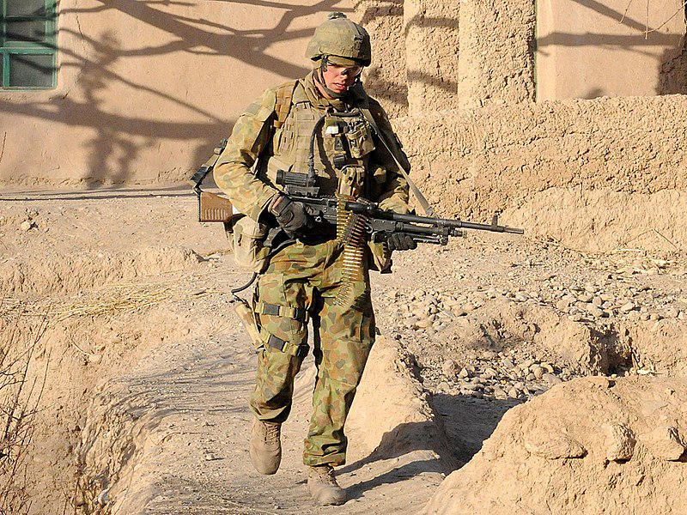

Generated Question - What general-purpose machine gun chambered for 7.62×51mm NATO replaced the M60 and is shown in the image with the Australian soldier?

Generated Answer - The FN MAG 58 designated as the General Support Machine Gun (GSMG).

--- Entry for custom_id: d5cd7d420dba11ecb1e81171463288e9 ---

Image Source 1 -

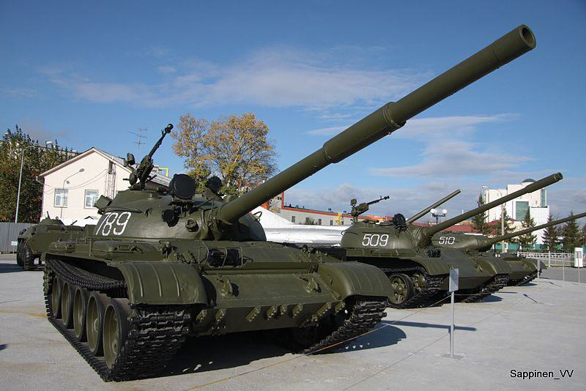

Caption for image source 1: Verkhnyaya Pyshma Tank Museum 2012 0071 Verkhnyaya Pyshma Tank Museum 2012.

Example Question - "What are some numbers of the tanks at the Verkhnyaya Pyshma Tank Museum?"

Example Answer - "The numbers of the tanks at the Verkhnyaya Pyshma Tank Museum are 789, 509 and 510."

Additional Text Source 1 - Funding for the museum came from the Ural Mining and Metallurgical Company, a major industrial conglomerate headquartered in Verkhnyaya Pyshma. The museum has since hosted several exhibitions, and in 2011 construction finished on a new visitor center. (from: UMMC Museum of Military and Automotive Equipment)

Generated Question - Are the tanks numbered 789, 509, and 510 at the Verkhnyaya Pyshma Tank Museum funded by the Ural Mining and Metallurgical Company?

Generated Answer - Yes, the tanks are part of the museum funded by the Ural Mining and Metallurgical Company.

--- Entry for custom_id: d5df50b20dba11ecb1e81171463288e9 ---

Example Question - Merlangius merlangus and Coregonus clupeaformis are both types of what?

Example Answer - Fish

Image Source 1 -

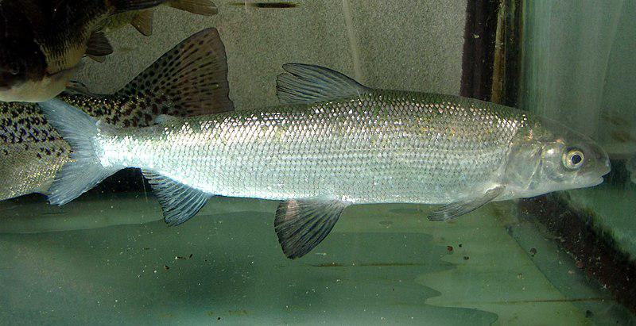

Generated Question - Are Coregonus clupeaformis and Coregonus lavaretus closely related species of freshwater fish?

Generated Answer - Yes, both are species of freshwater whitefish in the genus Coregonus.

--- Entry for custom_id: d5ded43e0dba11ecb1e81171463288e9 ---

Example Question - The nobility of what country that party sponsored exploratory voyages can be traced back to Alfonso VI of Leon?

Example Answer - Portugal.

Image Source 1 -

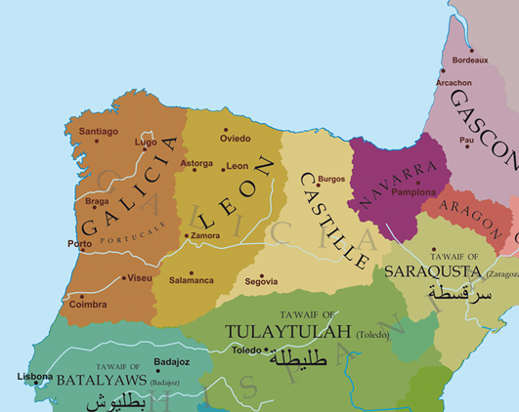

Generated Question - Which kingdom's nobility, linked to Alfonso VI of Leon, controlled the region between the Minho and Douro Rivers shown on the map?

Generated Answer - The kingdom of León's nobility controlled that region.

--- Entry for custom_id: d5d115100dba11ecb1e81171463288e9 ---

Example Question - Which more clearly defines a belief that just about anything has a spirit; Religion or Animism?

Example Answer - Animism

Image Source 1 -



Generated Question - How does animism as shown in the image relate to the broader concept of religion described in the text?

Generated Answer - Animism is a type of religion that believes all things have a spiritual essence.

--- Entry for custom_id: d5dc26bc0dba11ecb1e81171463288e9 ---

Example Question - What is the more common form of hermaphroditism of producing reproductive cells at different life stages, where a born female changes into a male some time?

Example Answer - Protogynous hermaphrodites.

Image Source 1 -



Generated Question - How does the sex change process in protogynous hermaphrodites like groupers and anemone fish relate to their social structure?

Generated Answer - They change sex based on social cues, such as absence of a male in the group.

--- Entry for custom_id: d5c88f760dba11ecb1e81171463288e9 ---

Image Source 1 -

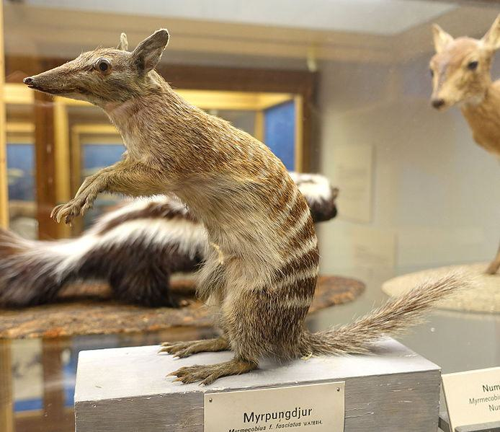

Caption for image source 1: Myrmecobius fasciatus - Swedish Museum of Natural History - Stockholm, Sweden - DSC00656 Exhibit in the Swedish Museum of Natural History - Stockholm, Sweden. Photography was permitted in the museum without restriction..

Image Source 2 -



Caption for image source 2: Siberian Chipmunk (Tamias sibiricus), Parc du Rouge-Cloître, Forêt de Soignes, Brussels (26040359560).

Example Question - "Is the snout of the Siberian Chipmunk longer relative to its body than the snout of the Myrmecobius Fasciatus?"

Example Answer - "No, the snout of the Siberian Chipmunk is not longer relative to its body than the snout of the Myrmecobius Fasciatus."

Additional Text Source 1 - It includes a single living species, the Siberian chipmunk (Eutamias sibiricus). The genus is often treated as a subgenus of Tamias, which is now restricted to the eastern chipmunk of North America. (from: Eutamias)

Generated Question - Are both the Myrmecobius fasciatus and Siberian chipmunk part of the same genus according to the additional text source?

Generated Answer - No, the Siberian chipmunk belongs to the genus Eutamias, not Myrmecobius.

--- Entry for custom_id: d5c2ab420dba11ecb1e81171463288e9 ---

Image Source 1 -



Caption for image source 1: WardenT&T T & T at Warden Centre in Markham.

Example Question - "What colors are used for the lettering sign on the front of the T&T Supermarket building in Markham?"

Example Answer - "The lettering on the sign for the T&T Supermarket in Markham is red, white, and green."

Additional Text Source 1 - General Motors Canada Canadian Technical Centre has been located in Markham since 2017, in the building which was formerly the Canadian head office of American Express from 1985–2015. (from: Markham, Ontario)

Generated Question - Is the T&T Supermarket in Markham located near the General Motors Canada Technical Centre?

Generated Answer - Yes, both are located in Markham, Ontario.

--- Entry for custom_id: d5c11ab60dba11ecb1e81171463288e9 ---

Image Source 1 -



Caption for image source 1: NNC-US-1796-G$2½-Turban Head (no stars) 1796 G$2 Turban Head (or Capped Bust) (no stars)Gold (fineness 0.9160), 20mm, 4.37g, designed by Robert ScotJN2015-6714-15.

Example Question - "Does the head on the Turban Head coin have long or short hair?"

Example Answer - "The head on the Turban Head coin has long hair."

Additional Text Source 1 - Also known as the "Turban Head", this interpretation of Liberty wearing a turban-like cap was designed by Robert Scot and was minted from 1796 to 1807, for a total of less than 20,000 coins minted. (from: Quarter eagle)

Generated Question - Was the Turban Head coin minted for more than a decade and does it feature Liberty with a turban-like cap?

Generated Answer - Yes, it was minted from 1796 to 1807 and features Liberty wearing a turban-like cap.

--- Entry for custom_id: d5cd57d60dba11ecb1e81171463288e9 ---

Image Source 1 -

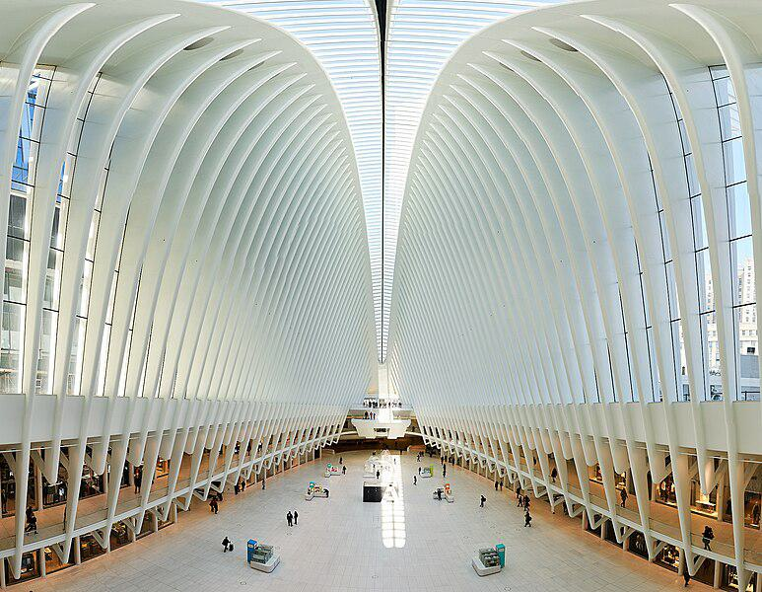

Caption for image source 1: Westfield Mall The Westfield Mall in One World Trade Center in New York CIty..

Example Question - "Are all the white ribs in the Westfield Mall in One World Trade Center in New York City the same length?"

Example Answer - "No, all of the white ribs in the Westfield Mall in the One World Trade Center in New York City do not have the same length."

Additional Text Source 1 - Westfield World Trade Center is a shopping mall at the World Trade Center complex in Manhattan, New York, that is operated and managed by Unibail-Rodamco-Westfield. (from: Westfield World Trade Center)

Generated Question - Is the Westfield Mall in One World Trade Center managed by the same company that operates other Westfield malls?

Generated Answer - Yes, it is managed by Unibail-Rodamco-Westfield, which operates other Westfield malls.

--- Entry for custom_id: d5c32cc00dba11ecb1e81171463288e9 ---

Image Source 1 -

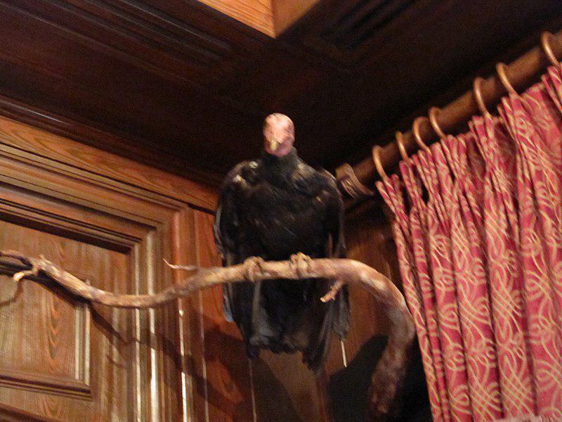

Caption for image source 1: Club 33 Vulture 2010.

Example Question - "What does the vulture hang between in Club 33?"

Example Answer - "The vulture hangs between the door and the curtains in club 33."

Additional Text Source 1 - The song "27 Club" by Ivy Levan, released as a promotional single for her debut album No Good (released in 2015), refers to the club. (from: 27 Club)

Generated Question - Is the vulture in Club 33 related to the song "27 Club" by Ivy Levan released in 2015?

Generated Answer - No, the vulture in Club 33 is not related to the song "27 Club" by Ivy Levan.

--- Entry for custom_id: d5ca8dda0dba11ecb1e81171463288e9 ---

Image Source 1 -

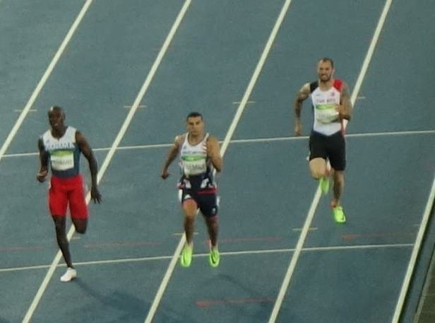

Caption for image source 1: Men's 200 metres event at the 2016 Summer Olympics, Olympic Stadium (Engenhão), Rio de Janeiro, Brazil (cropped) Men's 200 metres event at the 2016 Summer Olympics, Olympic Stadium (Engenhao), Rio de Janeiro, Brazil..

Image Source 2 -

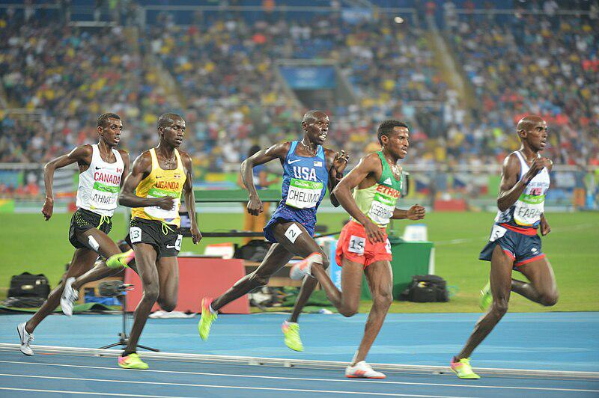

Caption for image source 2: Spc. Paul Chelimo wins silver medal in 5,000 meters at Rio Olympic Games photos by Tim Hipps, IMCOM Public Affairs (29090421706).

Example Question - "In the 5,000 and 200 meters events at the Rio Olympic Games, did the athletes wear their country's name across their chest?"

Example Answer - "Yes, they wore their country's name across their chest."

Additional Text Source 1 - He previously participated in two other Olympic games and three events (The men's 400 meters and men's 4 x 400 meters relay in Sydney, and the men's 400 meters hurdles in Athens), winning silver medals in the Sydney relay and the Athens hurdles race. (from: Jamaica at the 2008 Summer Olympics)

Generated Question - Did the athletes in both the 200 meters and 5,000 meters events at the Rio Olympics wear bib numbers during their races?

Generated Answer - Yes, athletes in both events wore bib numbers during their races.

--- Entry for custom_id: d5c43bec0dba11ecb1e81171463288e9 ---

Image Source 1 -

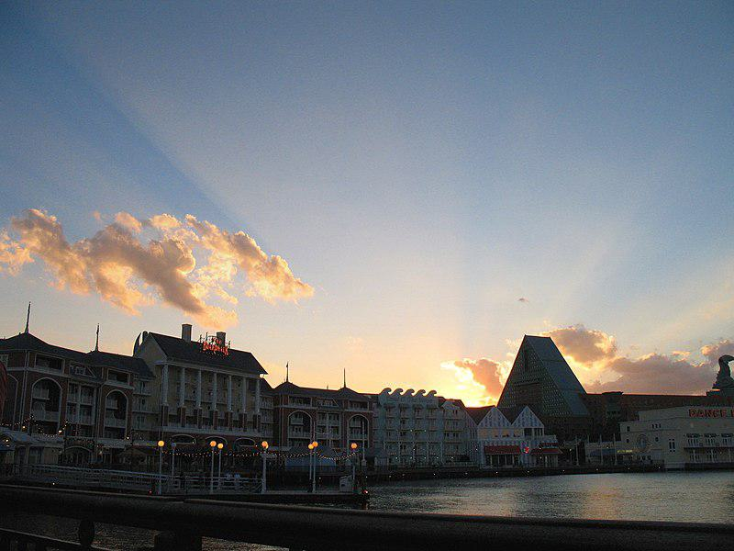

Caption for image source 1: DISNEYWORLD BOARDWALK RESORT - panoramio.

Image Source 2 -

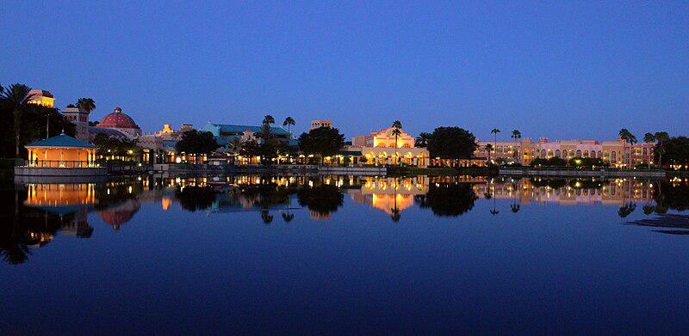

Caption for image source 2: Coronado Blue (33706136420).

Example Question - "Are Disney's Coronado Springs Resort and Disneyworld's Boardwalk Resort both located on the water?"

Example Answer - "Yes, Disney's Coronado Springs Resort and Disneyworld's Boardwalk Resort are both located on the water."

Additional Text Source 1 - Disney's Coronado Springs Resort is a resort hotel at the Walt Disney World Resort that opened on August 1, 1997. The resort is located in the Animal Kingdom Resort Area. (from: Disney's Coronado Springs Resort)

Generated Question - Are both Disney's Boardwalk Resort and Coronado Springs Resort located near water and part of Walt Disney World Resort?

Generated Answer - Yes, both resorts are near water and part of Walt Disney World Resort.

--- Entry for custom_id: d5d1f34a0dba11ecb1e81171463288e9 ---

Example Question - What literature has a number of Germanic gods mentioned in it that can include Týr and Ullr?

Example Answer - Old Norse.

Image Source 1 -

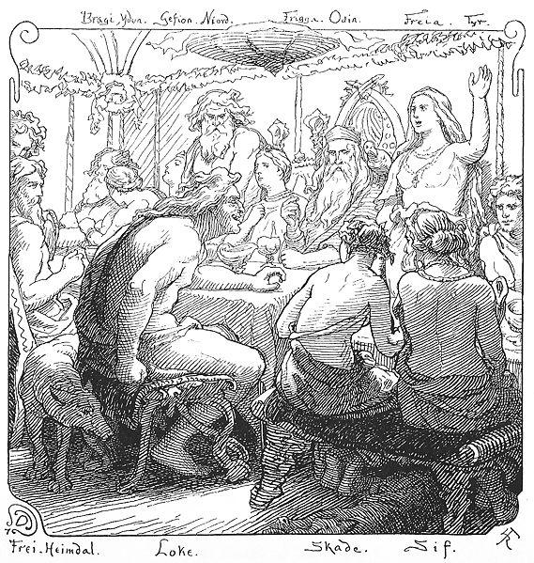

Generated Question - Which group of Germanic gods does Týr belong to, and what is the primary role of their chief god Odin?

Generated Answer - Týr belongs to the Æsir, whose chief god Odin is primarily the god of war and wisdom.

--- Entry for custom_id: d5ccad4a0dba11ecb1e81171463288e9 ---

Image Source 1 -

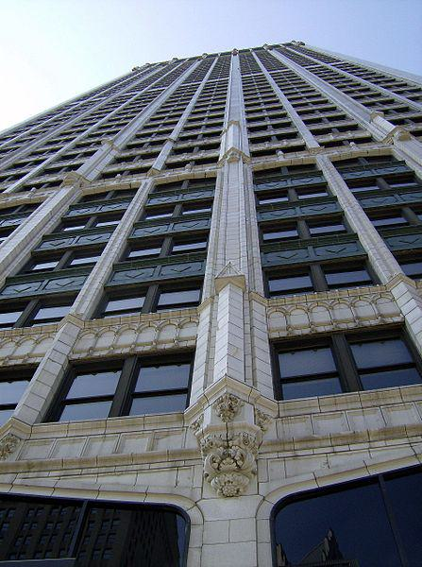

Caption for image source 1: CadillaclookingupDetroit Cadillac Tower in Detroit, Michigan, United States..

Image Source 2 -

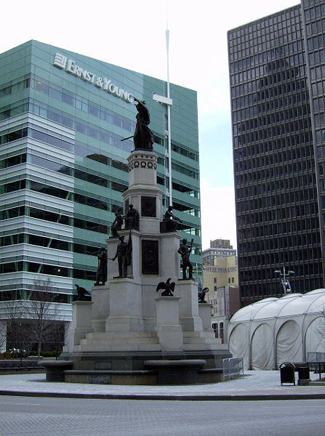

Caption for image source 2: MichiganSoldiersSailors.

Example Question - "Is the Stone on the Michigan Soldiers & Sailors Monument the same Shade of Grey as the facade of the Cadillac building in Detroit?"

Example Answer - "No, the Stone on the Michigan Soldiers & Sailors Monument is not the same Shade of Grey as the facade of the Cadillac building in Detroit."

Additional Text Source 1 - The Michigan Soldiers' and Sailors' Monument is situated within the traffic circle of the intersection of Woodward Avenue, Michigan Avenue, Monroe Street, Fort Street, and Cadillac Square. (from: Michigan Soldiers' and Sailors' Monument)

Generated Question - Are both the Cadillac Tower and the Michigan Soldiers' and Sailors' Monument located near Cadillac Square in Detroit?

Generated Answer - Yes, both are located near Cadillac Square in Detroit.

--- Entry for custom_id: d5d5bade0dba11ecb1e81171463288e9 ---

Example Question - Libor which is calculated by the Intercontinental Exchange stands for what?

Example Answer - London Inter-bank Offered Rate

Image Source 1 -

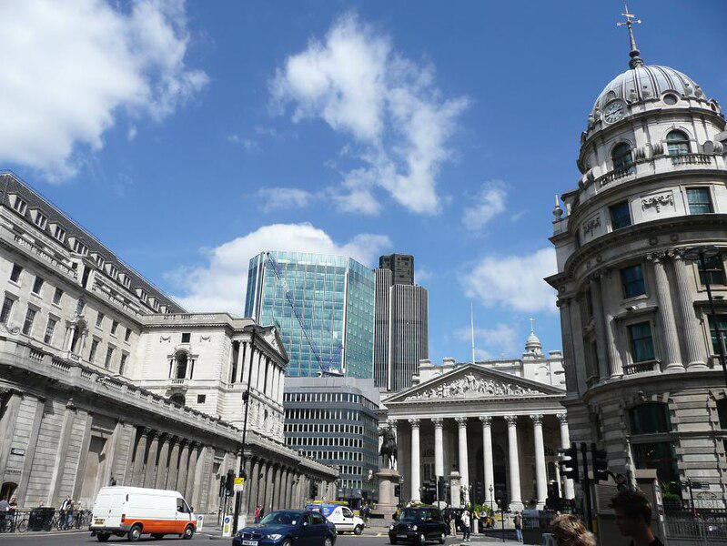

Generated Question - How is Libor related to the City of London as shown in the image and described in the texts?

Generated Answer - Libor is named after the City of London where the leading banks calculate the rate.

--- Entry for custom_id: d5dfa6d40dba11ecb1e81171463288e9 ---

Example Question - The method of modeling what, which in biology is the similarity due to shared ancestry between a pair of structures or genes in different taxa, is based on the observation that protein tertiary structure is better conserved than amino acid sequence?

Example Answer - homology

Image Source 1 -

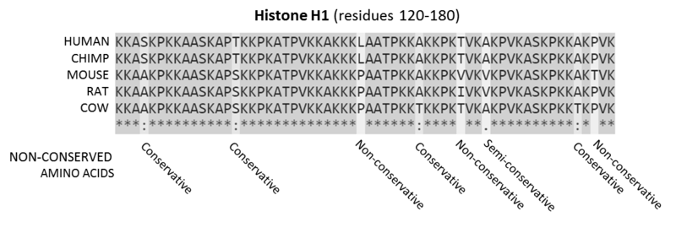

Generated Question - How does the sequence alignment of mammalian histone proteins support the principle that protein tertiary structure is better conserved than amino acid sequence in homology modeling?

Generated Answer - The alignment shows conserved residues despite some mutations, indicating structural conservation beyond sequence variation.

--- Entry for custom_id: d5d13d100dba11ecb1e81171463288e9 ---

Example Question - Which operated in a wider market: American Association of Professional Baseball or United League Baseball?

Example Answer - American Association of Professional Baseball operated in a wider market.

Image Source 1 -



Generated Question - Which league operated longer, United League Baseball or the American Association of Professional Baseball?

Generated Answer - The American Association of Professional Baseball operated longer.

--- Entry for custom_id: d5c7276c0dba11ecb1e81171463288e9 ---

Image Source 1 -

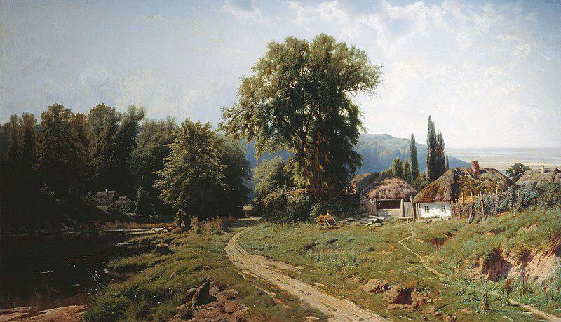

Caption for image source 1: KonstantinKryzhitsky HutorVMalorossii 1884 Khutir (or hamlet) in Little Russia, 1884.

Example Question - "What material is the roof of the house in Constantin Kryjitski's "Khutir (or hamlet) in Little Russia, 1884" made from?"

Example Answer - "The roof of the house is thatched in Constantin Kryjitski's "Khutir (or hamlet) in Little Russia, 1884."

Additional Text Source 1 - In his prominent work Two Russian nationalities, Kostomarov uses Southern Russia and Little Russia interchangeably. Mykhailo Drahomanov titled his first fundamental historic work Little Russia in its literature (1867–1870). (from: Little Russia)

Generated Question - Does the painting "Khutir in Little Russia, 1884" depict a rural area consistent with the historical use of "Little Russia" for Southern Russia?

Generated Answer - Yes, the painting shows a rural hamlet consistent with the historical term "Little Russia" for Southern Russia.

--- Entry for custom_id: d5d17d980dba11ecb1e81171463288e9 ---

Example Question - Does the auriculotemporal nerve run parallel to the superficial iliac circumflex artery?

Example Answer - No, the superficial iliac circumflex artery is in the leg and the auriculotemporal nerve is in the head.

Image Source 1 -

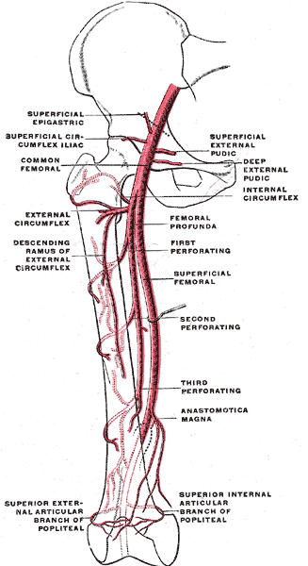

Generated Question - Do the auriculotemporal nerve and the superficial circumflex iliac artery run alongside the femoral artery in the thigh?

Generated Answer - No, the auriculotemporal nerve is in the head, while the superficial circumflex iliac artery runs near the femoral artery in the thigh.

--- Entry for custom_id: d5d0c7220dba11ecb1e81171463288e9 ---

Example Question - What is the basic difference between the reflectivity on individual PPI angles and composite reflectivity?

Example Answer - The reflectivity on individual PPI angles show the precipitation intensity at that specific angle above the horizon while the composite reflectivity is the maximum dBZ reflectivity from any of the reflectivity angles of the NEXRAD weather radar

Image Source 1 -

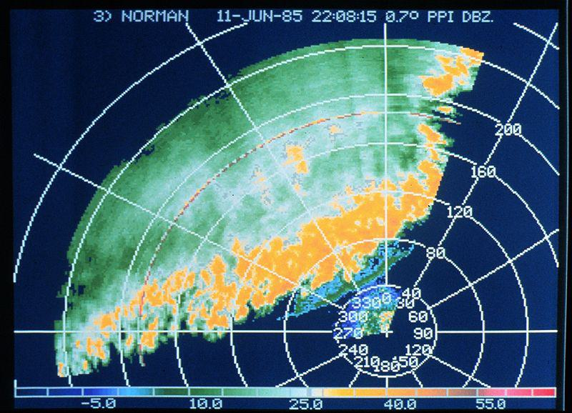

Generated Question - How does the reflectivity shown in the thunderstorm line image relate to the precipitation intensity at specific PPI angles?

Generated Answer - The reflectivity in the image shows precipitation intensity at a specific PPI angle above the horizon.

--- Entry for custom_id: d5c95f6e0dba11ecb1e81171463288e9 ---

Image Source 1 -

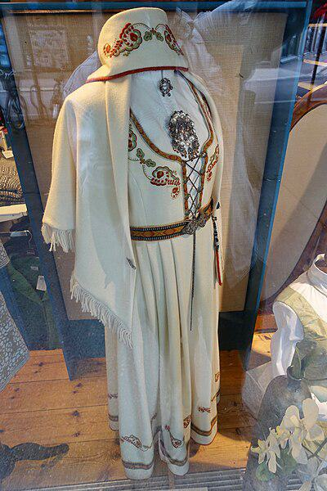

Caption for image source 1: Vestfoldbunad Den broderte Segerbrandt-bunaden For sale at Vestfold-Stua in Tønsberg, Norway (reconstructed traditional folk costume of Vestfold county with embroidery) 2019-08-27 5281 Brodert vestfoldbunad / Segerbrandt-bunaden; Norwegian bunad (reconstructed traditional/folk costume) of Vestfold County, model with embroidery designed by Petrine Segerbrandt (born 1880), for sale at Vestfold-Stua women's clothing store in Tnsberg, Norway..

Image Source 2 -



Caption for image source 2: Amerindian woman in her traditional clothes.png photo of an amerindian woman in her traditional clothes.

Example Question - "Can floral designs be found in both the traditional folk costume of Vestfold county, Norway and traditional Amerindian women clothing?"

Example Answer - "Yes, floral designs can be found in both the traditional folk costume of Vestfold county, Norway and traditional Amerindian women clothing."

Additional Text Source 1 - Norwegians from Setesdal still wear this time-honored traditional costume as a bunad today. Such long-standing folk costume traditions can be found all over Norway, but not all regions have retained these traditions as well as areas like Setesdal. (from: Bunad)

Generated Question - Do both the Vestfoldbunad and Setesdal bunad represent preserved traditional Norwegian folk costumes with embroidery?

Generated Answer - Yes, both Vestfoldbunad and Setesdal bunad are preserved traditional Norwegian folk costumes featuring embroidery.

--- Entry for custom_id: d5cc2ab40dba11ecb1e81171463288e9 ---

Image Source 1 -

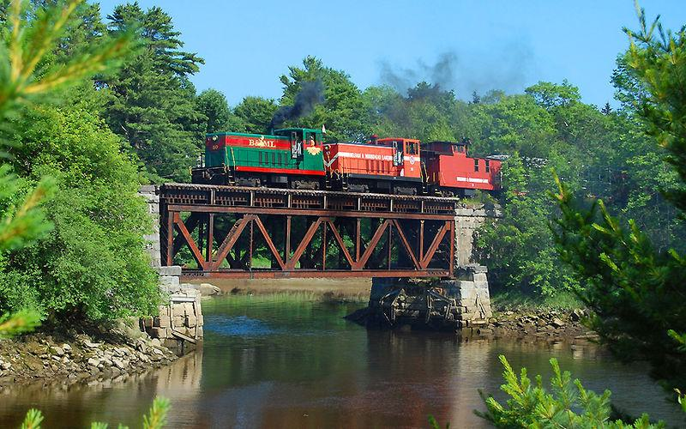

Caption for image source 1: BMLRR City Point Trestle (MP 2.0) BML#50 and BML#53, a pair of late 1940's GE 70-ton diesel electric locomotives, crossing the BML's City Point Trestle (MP 2.0) at the "Head of Tide" heading inland from Belfast, Maine, on the 33-mile Belfast and Moosehead Lake Railroad main line to Burnham Junction..

Example Question - "What runs under the train tracks on the BML's City Point Trestle?"

Example Answer - "Water runs under the train tracks on the BML's City Point Trestle."

Additional Text Source 1 - This milestone was also marked by the opening of the Crown Point Ravine trestle and the first crossing of the work train, engine No. 1 plus four cars, followed closely behind by engine No. 2, plus four cars (1 revenue). (from: Virginia and Truckee Railroad)

Generated Question - Does the BML's City Point Trestle and the Crown Point Ravine trestle both support trains crossing over natural features?

Generated Answer - Yes, both trestles support trains crossing over natural features like water or ravines.

--- Entry for custom_id: d5c2c5640dba11ecb1e81171463288e9 ---

Image Source 1 -

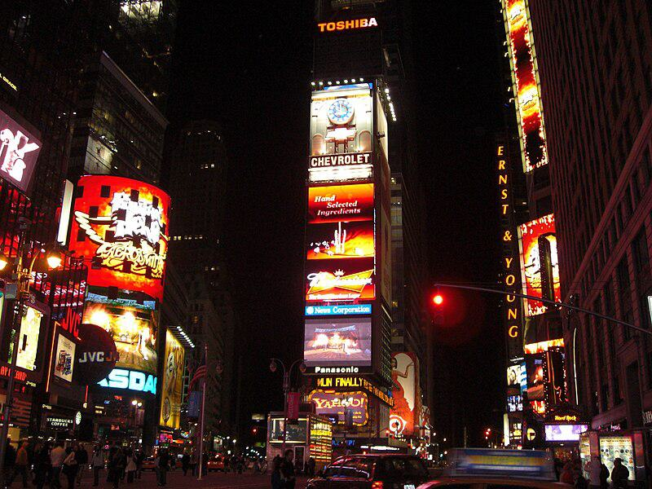

Caption for image source 1: Times Square, New York, USA1 Times Square, New York, USA.

Example Question - "Does Times Square feature ads from Chevrolet?"

Example Answer - "Chevrolet ads are featured in Times Square."

Additional Text Source 1 - Following its sale to Lehman Brothers in 1995, One Times Square was re-purposed with advertising billboards on its facade to take advantage of its prime location within the square. (from: One Times Square)

Generated Question - Is the presence of multiple illuminated advertisements on One Times Square a result of its repurposing after being sold to Lehman Brothers?

Generated Answer - Yes, One Times Square was repurposed with many illuminated ads after its sale to Lehman Brothers.

--- Entry for custom_id: d5de28a40dba11ecb1e81171463288e9 ---

Example Question - For the individual who discovered the law of gravitation, what did his writings suggest towards the main goals of alchemy?

Example Answer - Discovery of the philosopher's stone and Elixir of Life.

Image Source 1 -

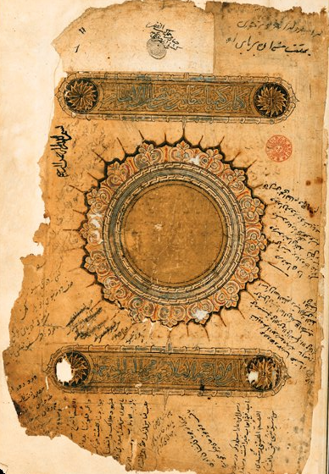

Generated Question - How do Newton's alchemical goals compare to the themes in Al-Ghazālī's 11th-century alchemy text shown in the image?

Generated Answer - Newton sought the philosopher's stone and Elixir of Life, while Al-Ghazālī's text focuses on alchemy and spiritual happiness.

--- Entry for custom_id: d5df9e3c0dba11ecb1e81171463288e9 ---

Example Question - What item of diving equipment called a manned torpedo is used by scuba divers to increase range underwater?

Example Answer - A diver propulsion vehicle.

Image Source 1 -

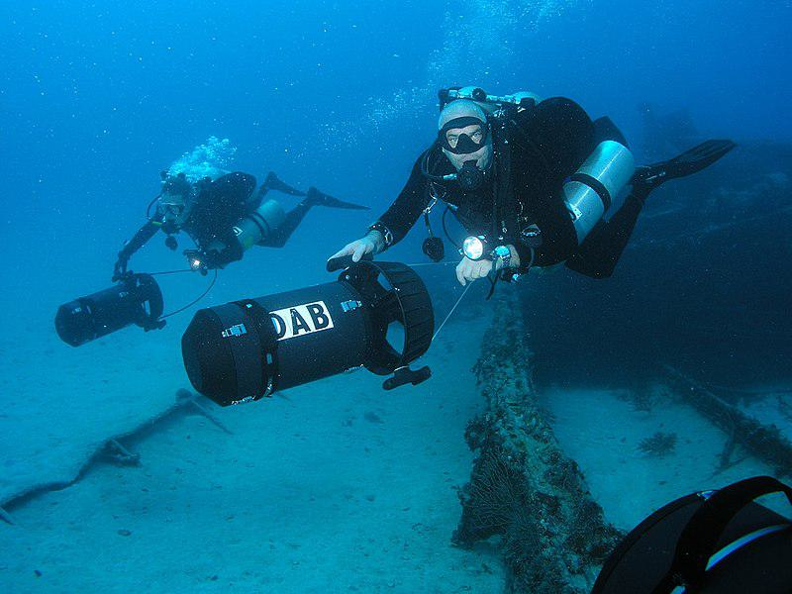

Generated Question - How were manned torpedoes used differently in World War II compared to modern diver propulsion vehicles shown in the image?

Generated Answer - Manned torpedoes were secret naval weapons for attacks, while modern DPVs increase divers' underwater range.

--- Entry for custom_id: d5c789820dba11ecb1e81171463288e9 ---

Image Source 1 -

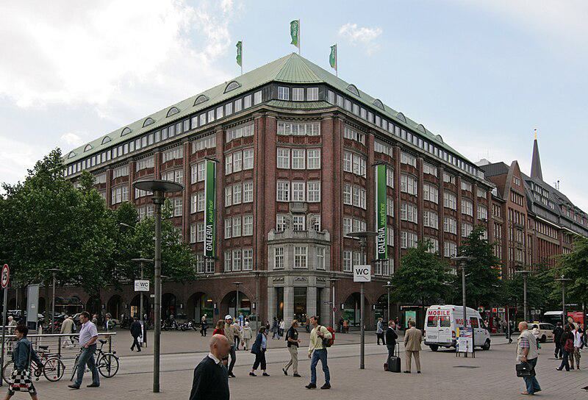

Caption for image source 1: Galeria Kaufhof Hamburg Galeria Kaufhof im Klopperhaus an der Monckebergstrae in Hamburg-Altstadt..

Example Question - "How many flags are atop the Galeria Kaufhof Hamburg?"

Example Answer - "There are three flags atop the Galeria Kaufhof Hamburg."

Additional Text Source 1 - Oldenburg, (renovation and remodeling once were started to rename this Horten-store, into Galeria Horten, but it was renamed Galeria Kaufhof in 1995, so it became the first Galeria Kaufhof) (from: Horten AG)

Generated Question - Is the Galeria Kaufhof Hamburg the first store to be renamed Galeria Kaufhof after remodeling like the Oldenburg store?

Generated Answer - No, the Oldenburg store was the first to be renamed Galeria Kaufhof in 1995 after remodeling.

--- Entry for custom_id: d5d9d22c0dba11ecb1e81171463288e9 ---

Example Question - What were the Messerschmitt Bf 109 and 152 air aces from Canada involved in?

Example Answer - World War II.

Image Source 1 -

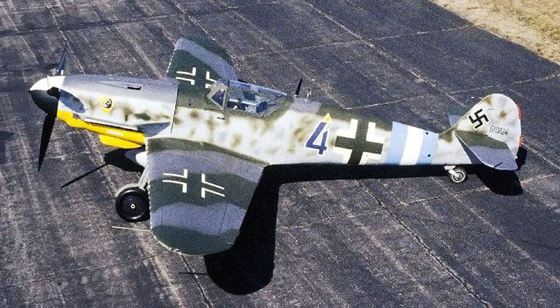

Generated Question - Which two aircraft were primarily used by German fighter aces during World War II alongside Canadian and Chinese aces?

Generated Answer - The Messerschmitt Bf 109 and the Focke-Wulf Fw 190.

--- Entry for custom_id: d5cb1c8c0dba11ecb1e81171463288e9 ---

Image Source 1 -



Caption for image source 1: 2011-06-15 Mycena sanguinolenta (Alb. & Schwein.) P. Kumm 151560.

Example Question - "Do the caps on the Mycena sanguinolenta have bumps?"

Example Answer - "The caps on the Mycena sanguinolenta have bumps."

Additional Text Source 1 - The other "bleeding Mycena" (M. haematopus) is readily distinguished from M. sanguinolenta by its larger size, different color, growth on rotting wood, and presence of a sterile band of tissue on the margin of the cap. (from: Mycena sanguinolenta)

Generated Question - Are the Mycena sanguinolenta mushrooms in the image growing on rotting wood like Mycena haematopus?

Generated Answer - No, Mycena sanguinolenta is not growing on rotting wood like Mycena haematopus.

--- Entry for custom_id: d5c72fb40dba11ecb1e81171463288e9 ---

Image Source 1 -

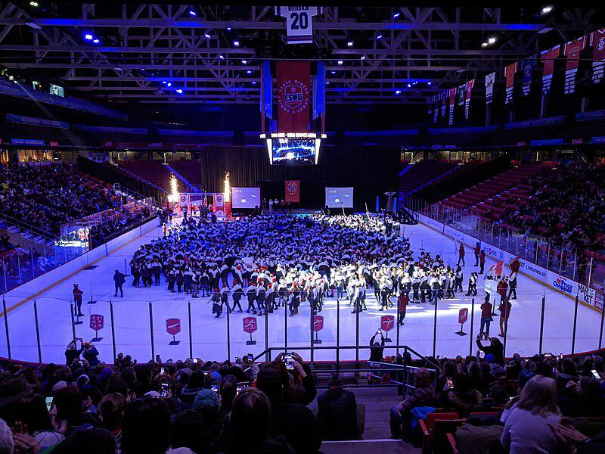

Caption for image source 1: EmpireStateWinterGames2020OpeningCeremony Opening ceremony for the 2020 Empire State Winter Games in the Olympic Center.

Example Question - "How many big screens surround the stage on the ice rink at the 2020 Empire State Winter Games opening ceremony?"

Example Answer - "There were three big screens surrounding the stage on the ice rink at the 2020 Empire State Winter Games opening ceremony."

Additional Text Source 1 - This was the first Winter Olympics and first Olympic Games opening ceremony under the IOC presidency of Thomas Bach. This was also the second consecutive Winter Olympic opening ceremony to be held in an indoor stadium. (from: 2014 Winter Olympics opening ceremony)

Generated Question - How does the indoor setting of the 2020 Empire State Winter Games opening ceremony compare to the 2014 Winter Olympics opening ceremony location?

Generated Answer - Both opening ceremonies were held indoors in stadiums.

--- Entry for custom_id: d5d62f3c0dba11ecb1e81171463288e9 ---

Example Question - The sticky emu bush was first formally described in what year?

Example Answer - Eremophila glutinosa was first formally described by Robert Chinnock in 1979.

Image Source 1 -

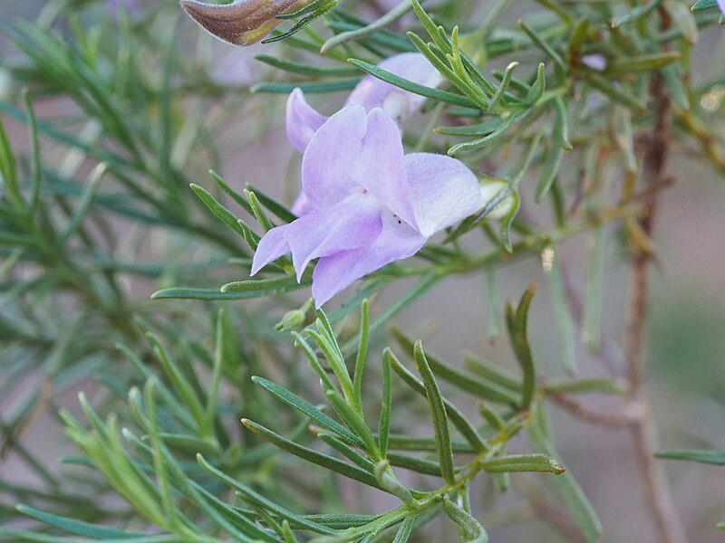

Generated Question - What characteristic of Eremophila glutinosa's leaves is reflected in its Latin name and visible in the image?

Generated Answer - The leaves are sticky and shiny, which is reflected in the Latin name "glutinosa."

--- Entry for custom_id: d5d1eb660dba11ecb1e81171463288e9 ---

Example Question - Was the NASCAR Winston Cup Series or the NASCAR Busch Series longer in 1992?

Example Answer - The Winston Cup was longer than the Busch Series.

Image Source 1 -



Generated Question - Did Joe Nemechek or Alan Kulwicki win the 1992 NASCAR Busch Series championship?

Generated Answer - Joe Nemechek won the 1992 NASCAR Busch Series championship.

--- Entry for custom_id: d5cc4d500dba11ecb1e81171463288e9 ---

Image Source 1 -

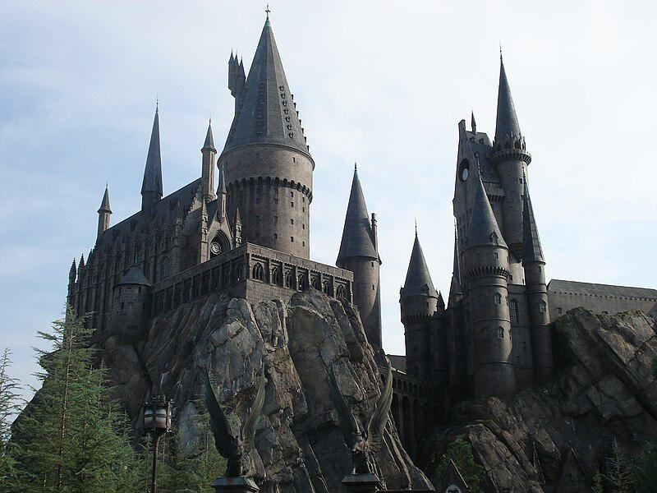

Caption for image source 1: Hogwarts's replica in Universal Studio, Orlando Hogwarts's replica in Universal Studio, Orlando.

Example Question - "What shape is the base of the tallest tower in Hogwarts's replica castle at Universal Studio?"

Example Answer - "It is a circle."

Additional Text Source 1 - Studio management became the third facet of Universal's operations, with the studio incorporated as a distinct subsidiary organization. Unlike other movie moguls, Laemmle opened his studio to tourists. (from: Universal Pictures)

Generated Question - Is the Hogwarts replica at Universal Studio built on a natural or rocky base, and how does this relate to Universal's approach to studio tourism?

Generated Answer - The Hogwarts replica is built on a rocky base, reflecting Universal's openness to tourists by creating immersive, realistic sets.

--- Entry for custom_id: d5db09da0dba11ecb1e81171463288e9 ---

Example Question - Eel and South Fork American are both names of what?

Example Answer - Rivers

Image Source 1 -

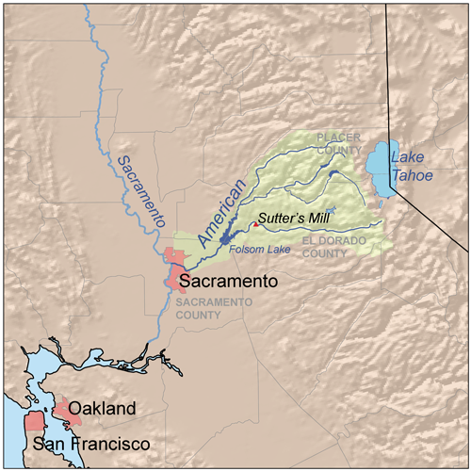

Generated Question - Which South Fork river flows into a lake shown on the map, and what is the name of that lake?

Generated Answer - The South Fork American River flows into Folsom Lake.

--- Entry for custom_id: d5c9dd7c0dba11ecb1e81171463288e9 ---

Image Source 1 -

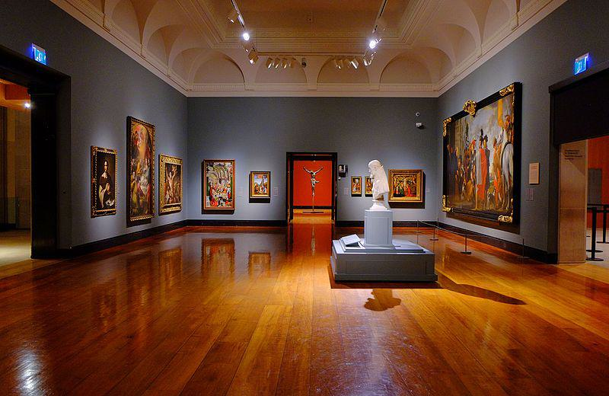

Caption for image source 1: Art Gallery of Ontario (23782351913).

Example Question - "What kind of lighting can be found in the Ontario Art Gallery?"

Example Answer - "Ceiling track lighting can be found in the Ontario Art Gallery."

Additional Text Source 1 - The Art Gallery of Ontario (AGO; French: Musée des beaux-arts de l'Ontario) is an art museum in Toronto, Ontario, Canada. The museum is located in the Grange Park neighbourhood of downtown Toronto, on Dundas Street West between McCaul and Beverley streets. (from: Art Gallery of Ontario)

Generated Question - Is the Art Gallery of Ontario located in a residential or downtown neighborhood of Toronto?

Generated Answer - It is located in a downtown neighborhood of Toronto.

--- Entry for custom_id: d5cf130a0dba11ecb1e81171463288e9 ---

Image Source 1 -



Caption for image source 1: University Club, Virginia Tech The University Club at Virginia Tech in Blacksburg, Virginia.

Example Question - "What color are the awnings over the entryway into the University Club at Virginia Tech?"

Example Answer - "The awnings over the entryway into the University Club at Virginia Tech are green."

Additional Text Source 1 - Virginia Tech (formally the Virginia Polytechnic Institute and State University and informally VT, VA Tech or VPI) is a public land-grant research university with its main campus in Blacksburg, Virginia. (from: Virginia Tech)

Generated Question - Is the University Club at Virginia Tech located on the main campus of the public land-grant research university in Blacksburg, Virginia?

Generated Answer - Yes, the University Club is located on Virginia Tech's main campus in Blacksburg.

--- Entry for custom_id: d5c1bd900dba11ecb1e81171463288e9 ---

Image Source 1 -

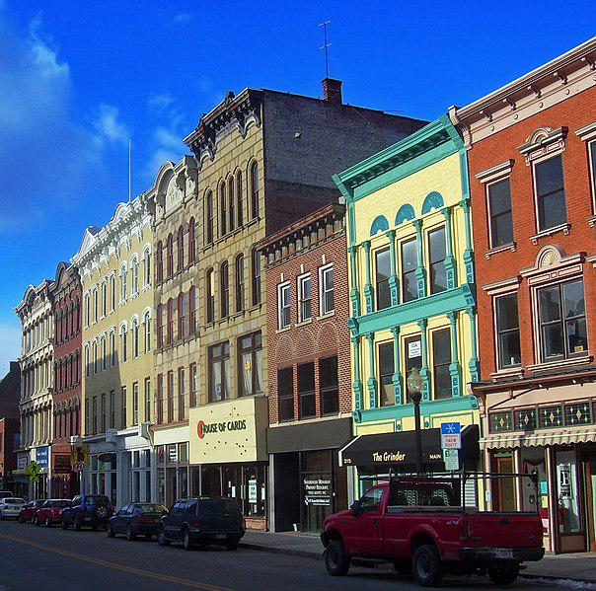

Caption for image source 1: Main Mall Row, Poughkeepsie, NY.

Image Source 2 -

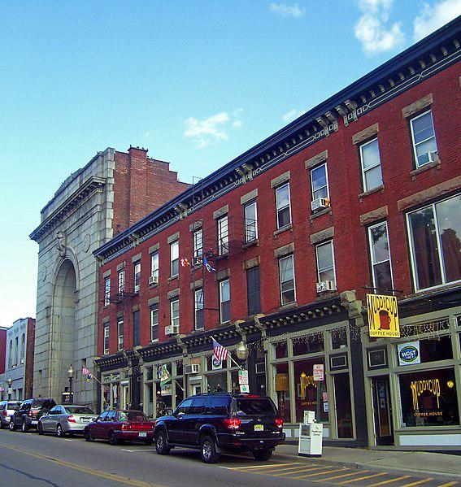

Caption for image source 2: Lower Main Street, Beacon, NY.

Example Question - "Does the Main Mall Row in Poughkeepsie, NY or the Lower Main Street building complex in Beacon, NY have a more colorful facade?"

Example Answer - "The Main Mall Row in Poughkeepsie, NY has a more colorful facade."

Additional Text Source 1 - Main Mall Row is an adjoining group of nine commercial buildings along the northeast corner of the intersection of Main and Garden streets in downtown Poughkeepsie, New York, United States. (from: Main Mall Row)

Generated Question - Which location, Main Mall Row in Poughkeepsie or Lower Main Street in Beacon, has more varied architectural styles visible in the building facades?

Generated Answer - Main Mall Row in Poughkeepsie shows more varied architectural styles in its facades.

--- Entry for custom_id: d5ca4bf40dba11ecb1e81171463288e9 ---

Image Source 1 -

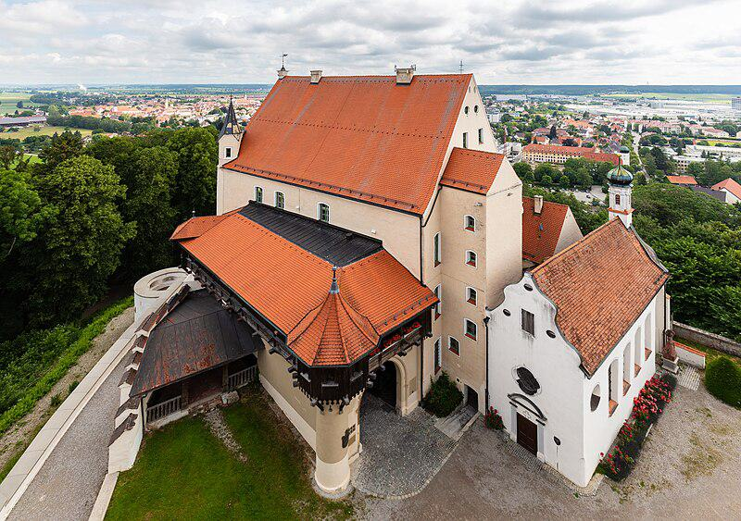

Caption for image source 1: Castillo Mindelburg, Mindelheim, Alemania, 2019-06-21, DD 31 Mindelburg Castle, Mindelheim, Germany.

Image Source 2 -

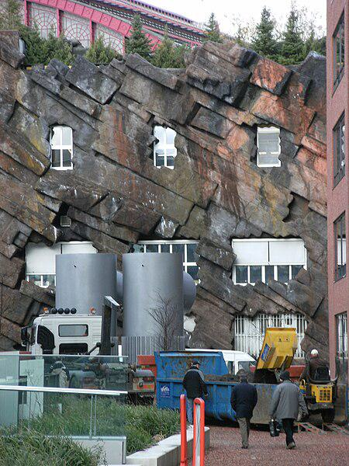

Caption for image source 2: Strange building with fake rock formations Antwerpen Strange building with fake rock formations Antwerpen..

Example Question - "What grows near both a Strange building with fake rock formations in Antwerpen and Mindelburg Castle?"

Example Answer - "Grass grows near both a Strange building with fake rock formations in Antwerpen and Mindelburg Castle."

Additional Text Source 1 - Fake rock formations were built around the second loop and around the first half of the lift hill, with a third formation just before the corkscrews. The entire ride was painted black and was renamed Demon. (from: Demon (roller coaster))

Generated Question - Do both Mindelburg Castle and the strange building in Antwerpen have natural or artificial elements incorporated in their structure?

Generated Answer - Mindelburg Castle has natural stone and traditional architecture, while the Antwerpen building has artificial fake rock formations.

--- Entry for custom_id: d5bfd9760dba11ecb1e81171463288e9 ---

Image Source 1 -

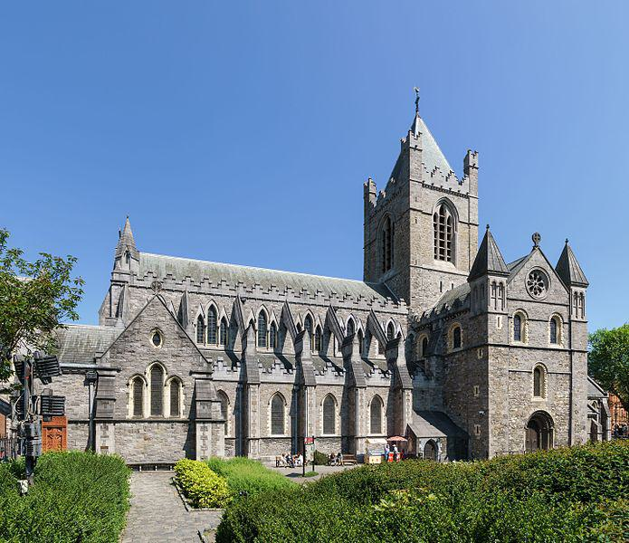

Caption for image source 1: Christ Church Cathedral, Dublin, 2016-06-03 Christ Church Cathedral.

Image Source 2 -

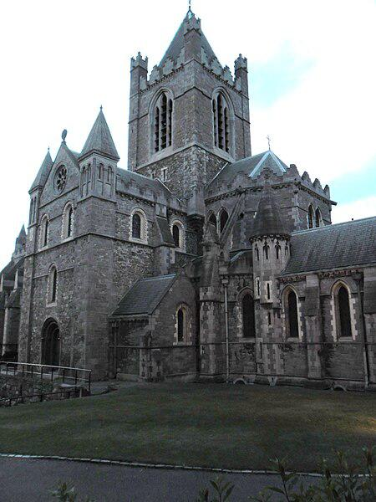

Caption for image source 2: Christ Church Cathedral, Dublin - panoramio.

Example Question - "Does Christ Church Cathedral, Dublin have taller greenery in front or on the sides?"

Example Answer - "The Christ Church Cathedral, Dublin has taller greenery on the sides than in front."

Additional Text Source 1 - Christ Church Cathedral, more formally The Cathedral of the Holy Trinity, is the cathedral of the United Dioceses of Dublin and Glendalough and the cathedral of the ecclesiastical province of the United Provinces of Dublin and Cashel in the (Anglican) Church of Ireland. (from: Christ Church Cathedral, Dublin)

Generated Question - Is Christ Church Cathedral, Dublin primarily associated with the Anglican Church or another denomination?

Generated Answer - Christ Church Cathedral, Dublin is primarily associated with the Anglican Church.

--- Entry for custom_id: d5ce91f00dba11ecb1e81171463288e9 ---

Image Source 1 -

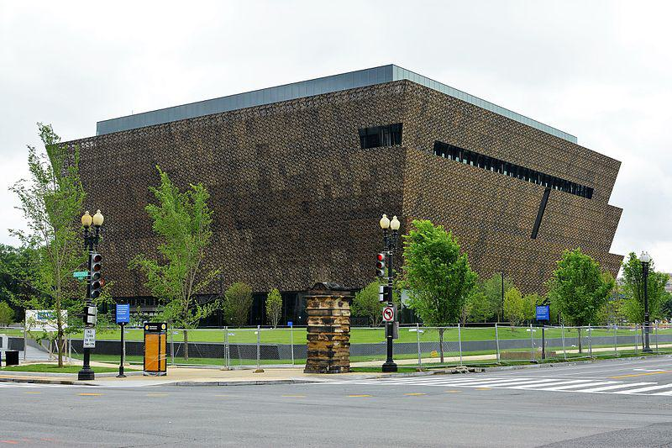

Caption for image source 1: National Museum of African American History and Culture.

Image Source 2 -

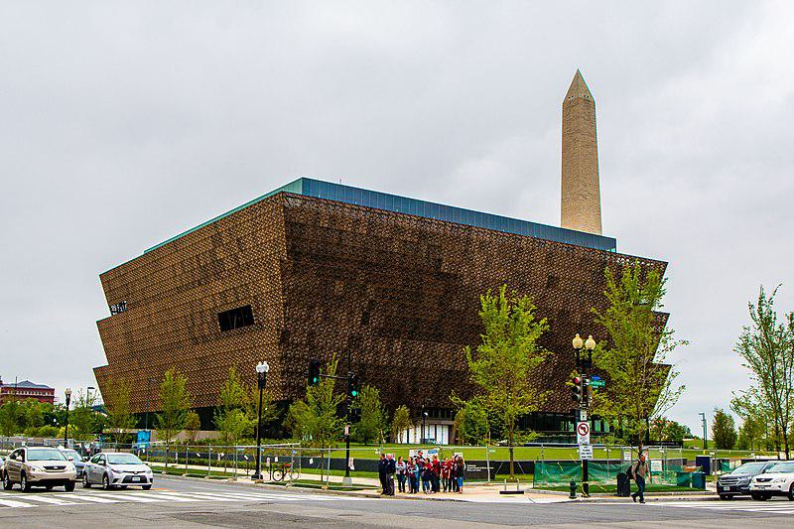

Caption for image source 2: African American Museum Washington, DC The African-American History Museum in Washington, DC.

Example Question - "Are there trees surrounding the African-American History Museum in Washington, DC?"

Example Answer - "Yes, there are trees surrounding the African-American History Museum in Washington, DC."

Additional Text Source 1 - The National Museum of African American History and Culture (NMAAHC) is a Smithsonian Institution museum located on the National Mall in Washington, D.C., in the United States. (from: National Museum of African American History and Culture)

Generated Question - Is the National Museum of African American History and Culture located near the Washington Monument on the National Mall?

Generated Answer - Yes, it is located near the Washington Monument on the National Mall.

--- Entry for custom_id: d5d2efd40dba11ecb1e81171463288e9 ---

Example Question - Which person, who purportedly created abthainries for his brother King Edgar, was called the abbot of Dunkeld?

Example Answer - Ethelred

Image Source 1 -

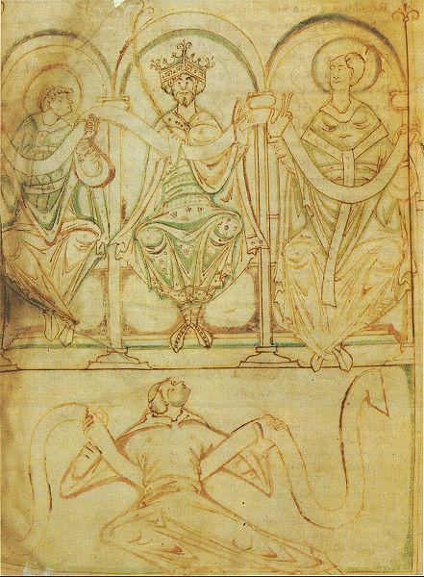

Generated Question - Which king, depicted seated between two saints in the manuscript, was the brother of the abbot of Dunkeld who created abthainries?

Generated Answer - King Edgar

--- Entry for custom_id: d5cc33560dba11ecb1e81171463288e9 ---

Image Source 1 -

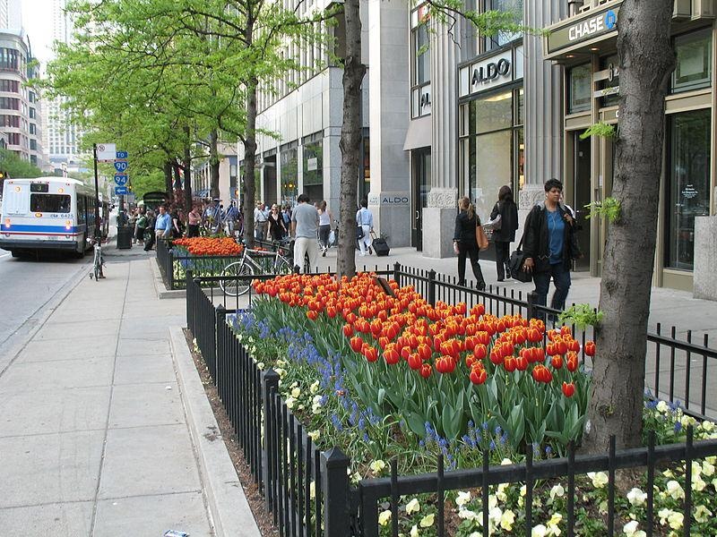

Caption for image source 1: 20070509 Tulip Days 2007 Tulip Days on The Magnificent Mile with CTA bus in view..

Image Source 2 -

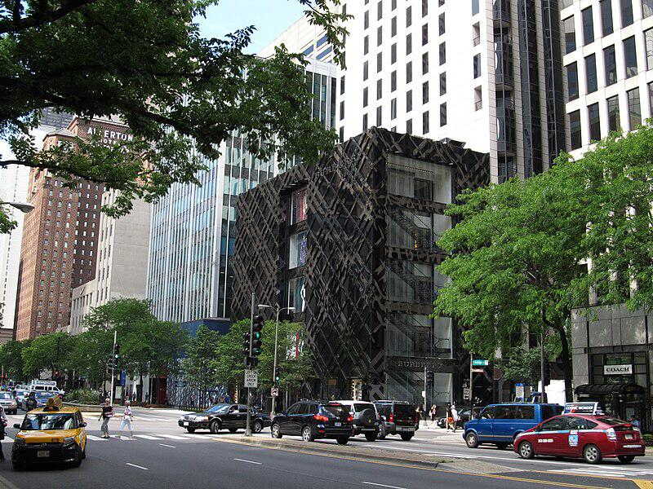

Caption for image source 2: The Magnificent Mile, Michigan Avenue, Chicago, Illinois (9181676490) The Magnificent Mile, sometimes referred to as The Mag Mile, is a prestigious section of Chicago's Michigan Avenue, running from the Chicago River to Oak Street in the Near North Side..

Example Question - "On The Magnificent Mile, what types of transportation service vehicles can be seen?"

Example Answer - "Taxis and buses can be seen on The Magnificent Mile."

Additional Text Source 1 - The Magnificent Mile, sometimes referred to as The Mag Mile, is an upscale section of Chicago's Michigan Avenue, running from the Chicago River to Oak Street in the Near North Side. (from: Magnificent Mile)

Generated Question - Are the tulip flower beds on The Magnificent Mile located near the upscale buildings shown in the area?

Generated Answer - Yes, the tulip flower beds are located near the upscale buildings on The Magnificent Mile.

--- Entry for custom_id: d5c283060dba11ecb1e81171463288e9 ---

Image Source 1 -



Caption for image source 1: Jeison Angulo USA-Columbia, FIFA U20 World Cup (18679461162) (cropped).

Image Source 2 -



Caption for image source 2: Philipp Lahm, Germany national football team (06) Philipp Lahm (FC Bayern Munich), german national football team This photograph was taken by user Steindy and released under the license(s) stated below..

Example Question - "Do both FC Bayern Munich and Colombia's national football team wear adidas jerseys?"

Example Answer - "Both the FC Bayern Munich and Colombia's national football team wear Adidas jerseys."

Additional Text Source 1 - The FC Bayern Munich Junior Team is the youth academy for German football club Bayern Munich. The Junior Team was created in 1902 and restructured in 1995. (from: FC Bayern Munich Junior Team)

Generated Question - Do the players from Colombia and Germany shown wear Adidas jerseys and play for teams with youth academies?

Generated Answer - Yes, both players wear Adidas jerseys, and Germany's Bayern Munich has a youth academy.

--- Entry for custom_id: d5c9722e0dba11ecb1e81171463288e9 ---

Image Source 1 -

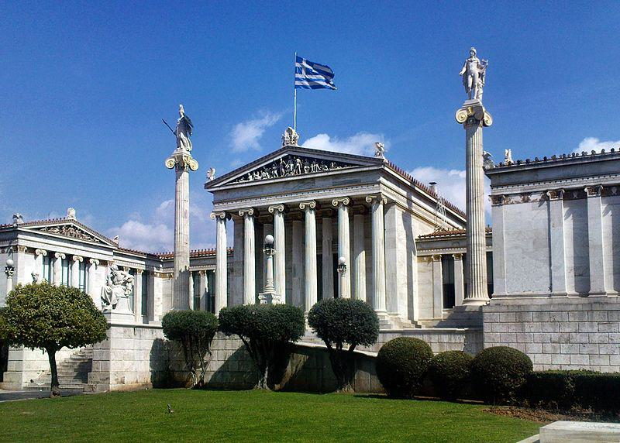

Caption for image source 1: Athens academy Academy of Athens.

Example Question - "At the Academy of Athens how many columns have a statue depicting a human on top of them?"

Example Answer - "Two columns have a statue depicting a human on top of them at the Academy of Athens."

Additional Text Source 1 - In addition, the generic term "the academy" is sometimes used to refer to all of academia, which is sometimes considered a global successor to the Academy of Athens. (from: Academy)

Generated Question - How many statues depicting humans are visible on columns at the Academy of Athens, and what broader concept does the term "academy" sometimes represent?

Generated Answer - Two statues are on columns, and "academy" can refer to all of academia globally.

--- Entry for custom_id: d5ce857a0dba11ecb1e81171463288e9 ---

Image Source 1 -

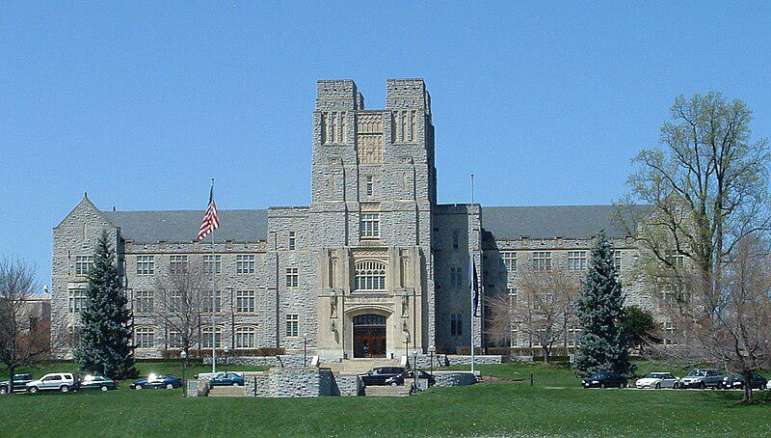

Caption for image source 1: Virginiatech-burrusshall-fromdrillfield Virginia Tech's Burruss Hall taken from the drillfield.

Example Question - "Is Virginia Tech's Burruss Hall symmetrical or asymmetrical?"

Example Answer - "Virginia Tech's Burruss Hall is symmetrical."

Additional Text Source 1 - Constructed in 1936 facing the center of the drill field and originally known as the Teaching and Administration Building, Burruss Hall is the main administration building on campus and the iconic symbol of Virginia Tech. (from: Campus of Virginia Tech)

Generated Question - Considering Burruss Hall's role and design, does its symmetrical architecture reflect its status as the main administration building at Virginia Tech?

Generated Answer - Yes, its symmetrical design reflects its importance as the main administration building.

--- Entry for custom_id: d5c987960dba11ecb1e81171463288e9 ---

Image Source 1 -



Caption for image source 1: Eighth Avenue Place - East Tower, 2010-09-29.

Image Source 2 -

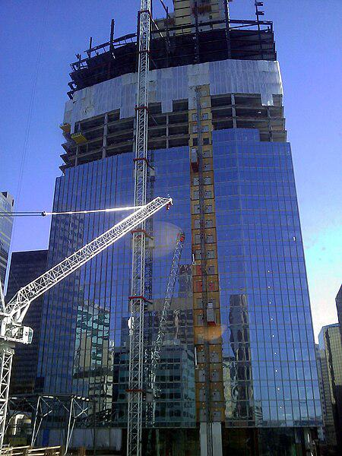

Caption for image source 2: Penny Lane Towers construction Construction of 8th Avenue place (Penny Lane Towers) in April 2010. Calgary, Alberta, Canada.

Example Question - "From which direction were the glass windows installed on the Penny Lane Towers?"

Example Answer - "The glass windows on the Penny Lane Towers were installed from the bottom up."

Additional Text Source 1 - In 1973 the Penny Lane Mall was built in downtown Calgary, Alberta, preserving the facade of a block of older buildings on 8th Avenue SW. (from: Penny Lane Mall)

Generated Question - Considering the construction stages shown, did the Penny Lane Towers maintain any historical facades during their development?

Generated Answer - Yes, the Penny Lane Towers preserved the facade of older buildings on 8th Avenue SW.

--- Entry for custom_id: d5d8173e0dba11ecb1e81171463288e9 ---

Example Question - Of Gaius Julius Caesar and Trajan, which would have existed further after the death of Jesus?

Example Answer - Trajan would have existed further after.

Image Source 1 -

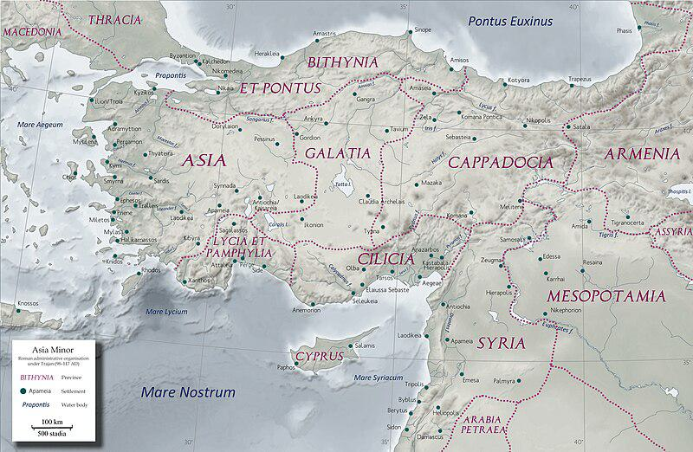

Generated Question - Considering the Roman provincial governance under Trajan and the Augustan Settlement, which emperor's policies more directly influenced the founding of Greek-type cities in Thracia?

Generated Answer - Trajan's policies more directly influenced the founding of Greek-type cities in Thracia.

--- Entry for custom_id: d5d2aa380dba11ecb1e81171463288e9 ---

Example Question - In the history of Lincolnshire and Lancashire counties, which county was recorded in the Domesday Book?

Example Answer - Lincolnshire was recorded in the Domesday Book as Lindsey, while Lancashire did not exist as a county in the Domesday Book.

Image Source 1 -

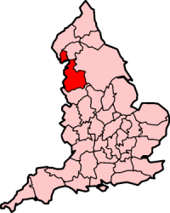

Generated Question - Which county, Lincolnshire or Lancashire, was historically divided into parts including Lindsey, and which is nicknamed "The Red Rose County"?

Generated Answer - Lincolnshire was divided into parts including Lindsey, while Lancashire is nicknamed "The Red Rose County."

--- Entry for custom_id: d5d5ff6c0dba11ecb1e81171463288e9 ---

Example Question - Darling River and Goulburn River are both located where?

Example Answer - New South Wales, Australia

Image Source 1 -

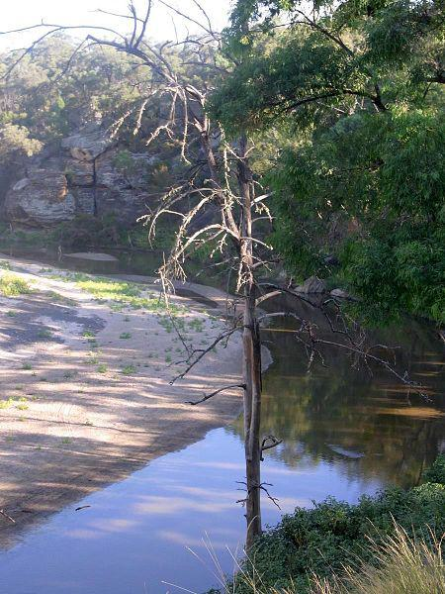

Generated Question - Do the rivers shown in the image and described in the texts both flow within New South Wales?

Generated Answer - Yes, both the Goulburn River and the Darling River flow within New South Wales.